# **PROJECT DOCUMENTATION**



**Project Description & Objective:**

The Workease Employee Service Hub is a unified digital portal designed to provide employees with quick access to essential workplace services. The hub simplifies daily operations by offering centralized booking, exploration, and service management features.

The objective of this project is to enhance employee convenience, streamline service accessibility, and modernize the user experience through a cohesive and intuitive portal.

# **Milestone 1: Creation of an instance**

**a) Log in to the instance using the credentials provided by the program.**  
Create new users records for every team member   
Distribute their instances so that they can work on their tasks.

**b) Create a New Application Scope**

1. Navigate to:  
    **System Applications → Studio**
2. Click **Create Application**.
3. Fill in:
   1. **Name**: Employee Hub
   2. **Scope**: Auto-generated (x_cdtd_employee_h)
   3. **Description**: A custom app to provide employees with quick access to essential workplace services.
4. Click **Create**.
5. Your new scoped app **Employee Hub** opens in Studio.

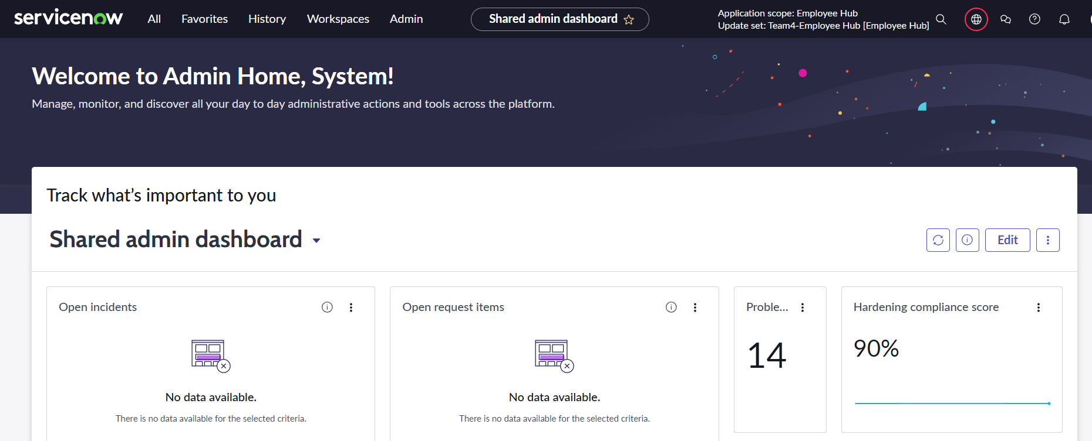

# **Milestone 2: Creating Custom Tables in Employee Hub**

## **Activity 1: Creating “Leave Planner” Table**

**Step 1: Navigate to System Definitions Tables**

* Log in to your ServiceNow instance.
* In the left application navigator, type tables in the search box .
* Click on Tables under System Definition.

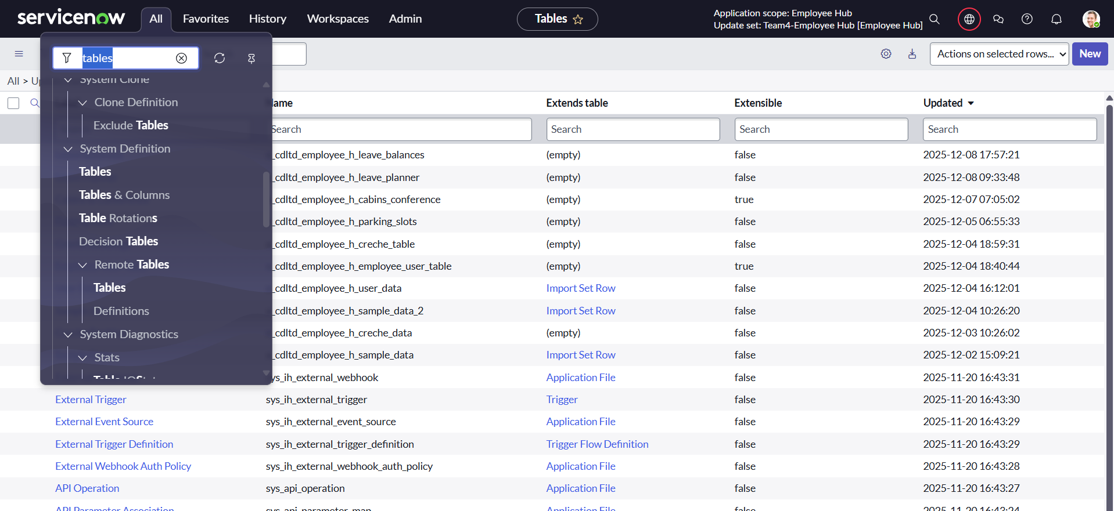

**Step 2: Create a New Table**

* In the Tables list view, click the New button at the top-right corner.
* In the new table form page:
  1. Enter **Leave Planner** details in the Label field.
  2. The Name field (API name) is automatically populated as  (x_cdltd_employee_h_leave_planner)
  3. Ensure the Application is set to Employee Hub

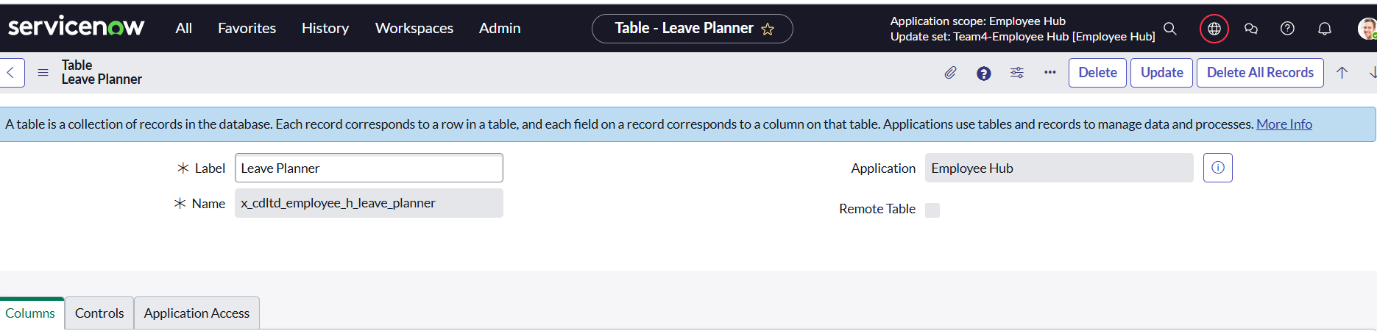

**Step 3: Add Columns to the Table**

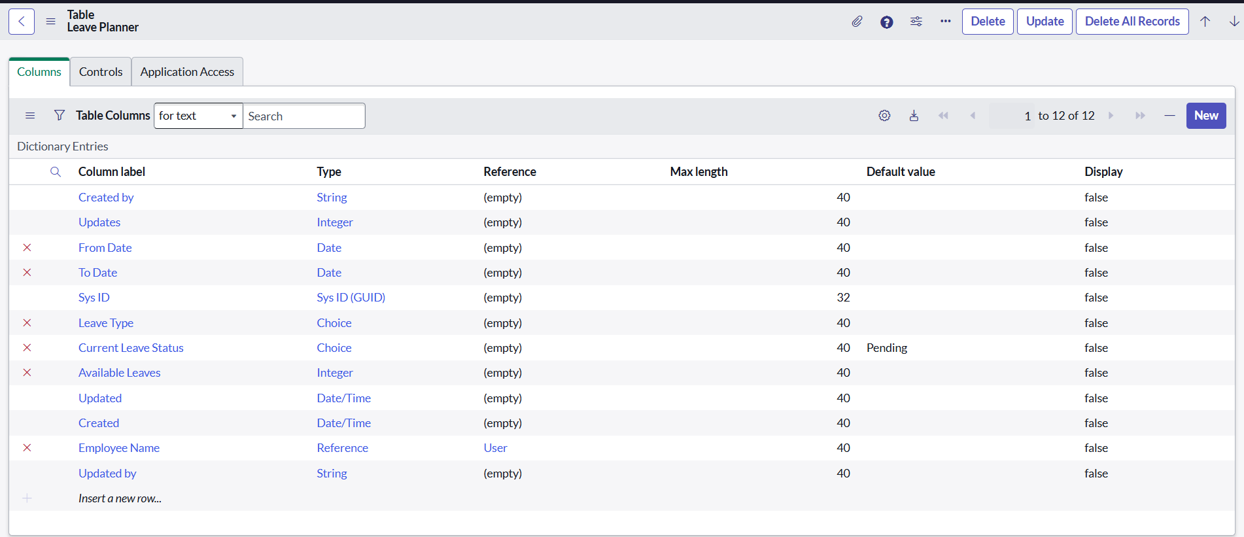

* After submission, you will see the Table form with the Columns tab selected.
* Click the New button in the Columns section to add each column.
* Add the following columns with their exact details (repeat for each column):

|  |  |  |  |  |  |
| --- | --- | --- | --- | --- | --- |
| **Column Label** | **Type** | **Reference (If Applicable)** | **Max Length** | **Default Value** | **Display** |
| From Date | Date |  | 40 |  | FALSE |
| To Date | Date |  | 40 |  | FALSE |
| Leave Type | Choice |  | 40 |  | FALSE |
| Current Leave Status | Choice |  | 40 | Pending | FALSE |
| Available Leaves | Integer |  | 40 |  | FALSE |
| Employee Name | Reference | User | 40 |  | FALSE |

**Step 4: Save the Table Structure**

* Once all columns are added and configured, click Update or Save to store the changes.

**Step 5: Verify Table List View**

* Navigate to the Leave Planner details module or list to view all entries.
* You should see the configured fields visible in the list view as below.

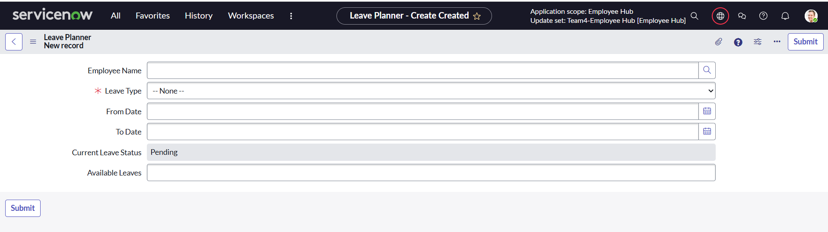

Note: We have used the Read Only/Mandatory fields in the Form builder instead of creating separate UI policies.

## **Activity 2: Creating “Cabin & Conference” Table**

**Step 1: Navigate to System Definition > Tables**

* Log in to your ServiceNow instance.
* From the left navigation pane, enter tables in the filter/search box.
* Click on Tables.



**Step 2: Create a New Table**

1. In the Tables list view, click the New button at the top right.
2. In the table creation form:
   * Enter the Label as Cabins & Conference details.
   * The Name (API name) will auto-populate (x_cdltd_employee_h_cabins_conference)
   * Ensure the Application is set to Employee Hub
3. Click Submit to create the table.

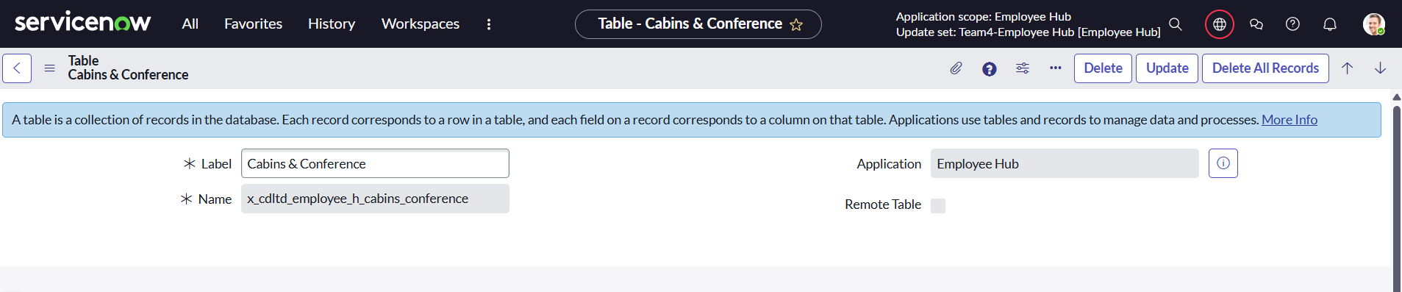

**Step 3: Add Columns to the Table**

* After submission, open your new table (Cabins & Conference) and go to the Columns tab.
* Click New to add each field with the following details:

|  |  |  |  |  |  |
| --- | --- | --- | --- | --- | --- |
| **Column Label** | **Type** | **Reference (If Applicable)** | **Max Length** | **Default Value** | **Display** |
| Type | Choice |  | 40 |  |  |
| From Time | Time |  | 40 |  | FALSE |
| End Time | Time |  | 40 |  | FALSE |
| Conference Room Name | Choice |  | 40 |  | FALSE |
| Cabin Number | Choice |  | 40 |  | FALSE |
| Date | Calendar Date/Time |  | 40 |  | FALSE |
| User Name | Reference | User | 32 |  | FALSE |
| Floor | Choice |  | 40 |  |  |
| Capacity | Choice |  | 40 |  | FALSE |
| Number | String |  | 40 | javascript:global.getNextObjNumberPadded(); | FALSE |
| Class | System Name Class |  | 80 | javascript:current.getTableName(); | FALSE |

* Repeat the "New" process for each field, ensuring the correct Type, Reference, Max Length, and Default Value are filled in appropriately.

**Step 4: Save the Table**

Click Update or Save to store the table and columns.

**Step 5: Verify Table List View**

* Navigate to the Cabins & Conference details module or list to view all entries.
* You should see the configured fields visible in the list view as below.

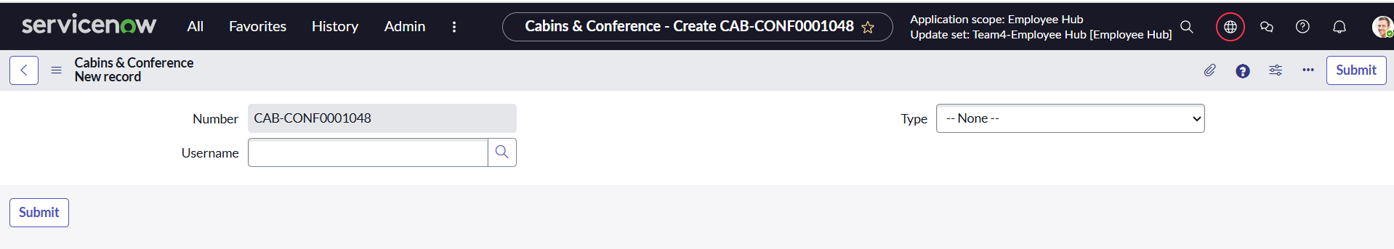

Note: We have used the Read Only/Mandatory fields in the Form builder instead of creating separate UI policies.

## **Activity 3: Creating “Parking Slots” Table**

**Step 1: Navigate to System Definition > Tables**

* Log in to your ServiceNow instance.
* From the left navigation pane, enter tables in the filter/search box.
* Click on Tables.



**Step 2: Create a New Table**

* In the Tables list view, click the New button at the top right.
* In the table creation form:
  1. Enter the Label as Parking Slots details.
  2. The Name (API name) will auto-populate (x_cdltd_employee_h_parking_slots).
  3. Ensure the Application is set to Employee Hub
* Click Submit to create the table.

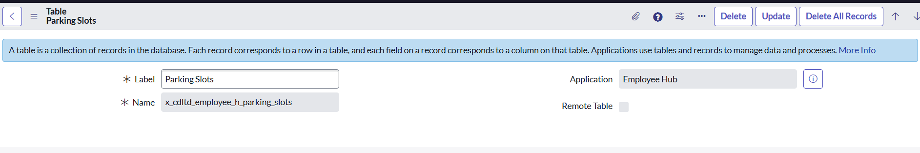

**Step 3: Add Columns to the Table**

* After submission, open your new table (Parking slots) and go to the Columns tab.
* Click New to add each field with the following details:

|  |  |  |  |  |  |
| --- | --- | --- | --- | --- | --- |
| **Column Label** | **Type** | **Reference (If Applicable)** | **Max Length** | **Default Value** | **Display** |
| Vehicle Number | String |  | 40 |  | FALSE |
| Date | Date |  | 40 |  | FALSE |
| Employee Name | String |  | 50 | |  |  | | --- | --- | | javascript: current.employee_name = curr... | [String](https://ind-nov-5453-0004.lab.service-now.com/sys_glide_object.do?sys_id=747127c1bf3320001875647fcf0739e0) | | FALSE |
| Booking Number | String |  | 6 | javascript:global.getNextObjNumberPadded(); | FALSE |
| Employee ID | Reference | User | 32 |  | FALSE |
| Vehicle Type | Choice | User | 32 |  | FALSE |
| Booking Confirmation | String |  | 40 | Not Booked Yet |  |
| Slot Number | String |  | 40 |  | FALSE |
| Active | True/False |  | 40 |  | FALSE |
| Occupancy | String |  | 40 | Not Yet Occupied | FALSE |

* Repeat the "New" process for each field, ensuring the correct Type, Reference, Max Length, and Default Value are filled in appropriately.

**Step 4: Save the Table**

Click Update or Save to store the table and columns.

**Step 5: Verify Table List View**

* + Navigate to the Parking slots details module or list to view all entries.
  + You should see all the configured fields visible in the list view.
* Verify list and form layout matches the requirements in the screenshots.

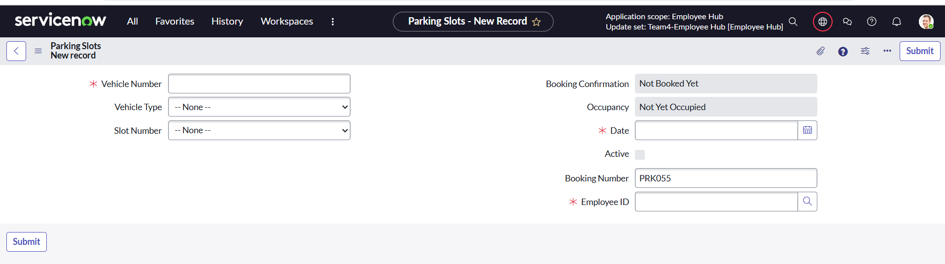

Note: We have used the Read Only/Mandatory fields in the Form builder instead of creating separate UI policies.

## **Activity 4: Creating “Creche Bookings” Table**

**Steps to Create and Configure**

1. Go to System Definition > Tables.
2. Create New Table:
   * Enter the label as " Creche Bookings ".
   * Save.

**Step 2: Create a New Table**

1. In the Tables list view, click the New button at the top right.
2. In the table creation form:
   * Enter the Label as Parking Slots details.
   * The Name (API name) will auto-populate (x_cdltd_employee_h_creche_table).
   * Ensure the Application is set to Employee Hub
3. Click Submit to create the table.

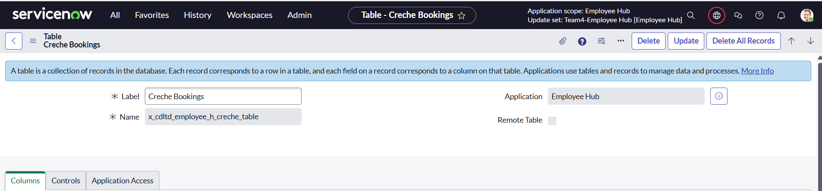

**Step 3: Add Columns to the Table**

* After submission, open your new table (Creche Bookings) and go to the Columns tab.
* Click New to add each field with the following details:

|  |  |  |  |  |
| --- | --- | --- | --- | --- |
| **Column Name** | **Type** | **Max Length** | **Reference** | **Display** |
| Creche Name | String | 40 |  | FALSE |
| Employee Email ID | String | 32 |  | FALSE |
| Care Taker Name | Choice | 40 |  | FALSE |
| Creche Slots Left | Integer | 40 |  | FALSE |
| Floor | Choice | 40 |  | FALSE |
| Age Group | Choice | 40 |  | FALSE |
| Creche Contact Number | Phone Number (E164) | 40 |  | FALSE |
| |  |  | | --- | --- | | Child name | [String](https://ind-nov-5453-0004.lab.service-now.com/sys_glide_object.do?sys_id=747127c1bf3320001875647fcf0739e0) | | String | 40 |  |  |
| |  |  | | --- | --- | | Booking Number | [String](https://ind-nov-5453-0004.lab.service-now.com/sys_glide_object.do?sys_id=747127c1bf3320001875647fcf0739e0) | | String | 40 | javascript:global.getNextObjNumberPadded(); | TRUE |
| Booking Date | Date | 40 |  | FALSE |
| Employee name | Reference | 40 | Employee User Table | FALSE |
| Employee ID | String | 32 |  | FALSE |
| Available Timing | Choice | 40 |  | FALSE |

* Repeat the "New" process for each field, ensuring the correct Type, Reference, Max Length, and Default Value are filled in appropriately.
* **Step 4: Save the Table**

Click Update or Save to store the table and columns.

**Step 5: Verify Table List View**

Navigate to the Creche bookings details module or list to view all entries.

You should see all the configured fields visible in the list view.

Verify list and form layout matches the requirements in the screenshots.

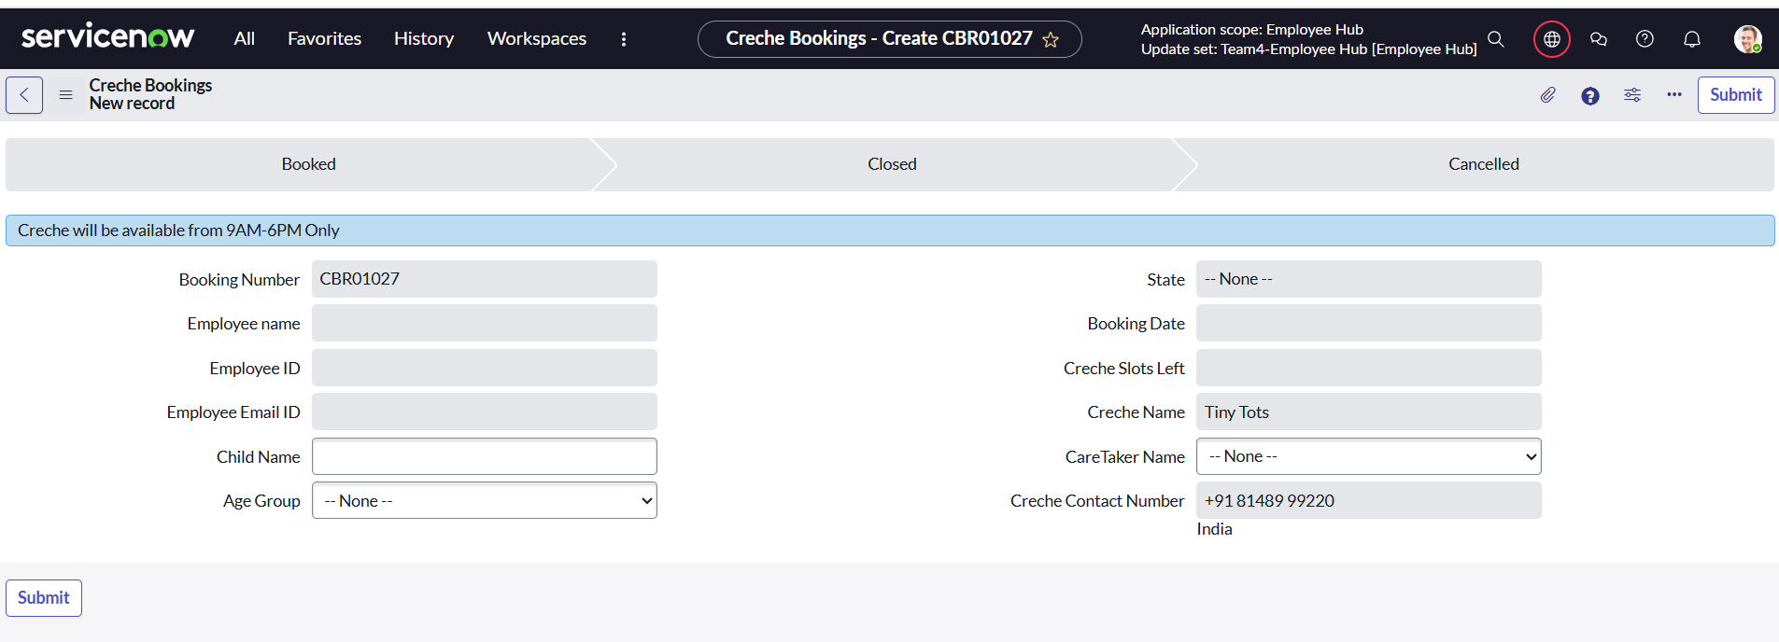

Note: We have used the Read Only/Mandatory fields in the Form builder instead of creating separate UI policies.

## **Activity 5: Creating “Employee User” Table**

**Step 1: Navigate to System Definitions Tables**

* Log in to your ServiceNow instance.
* In the left application navigator, type tables in the search box .
* Click on Tables under System Definition.

**Step 2: Create a New Table**

* In the Tables list view, click the New button at the top-right corner.
* In the new table form page:
  1. Enter **Employee User Table** details in the Label field.
  2. The Name field (API name) is automatically populated as (x_cdltd_employee_h_employee_user_table) the table.
  3. Ensure the Application is set to Employee Hub

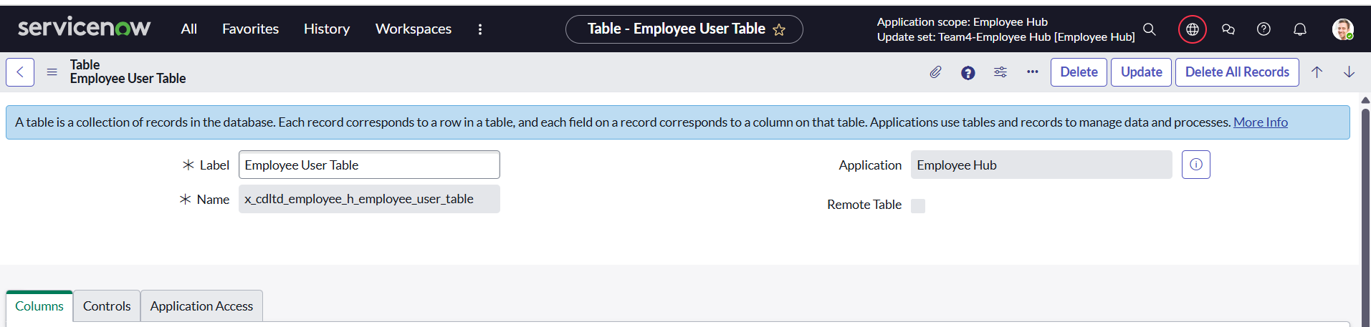

**Step 3: Add Columns to the Table**

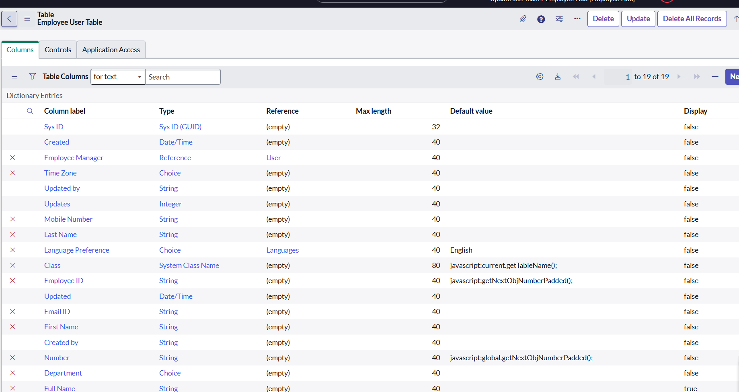

1. After submission, you will see the Table form with the Columns tab selected.
2. Click the New button in the Columns section to add each column.
3. Add the following columns with their exact details (repeat for each column):

|  |  |  |  |  |  |
| --- | --- | --- | --- | --- | --- |
| **Column Label** | **Type** | **Reference (If Applicable)** | **Max Length** | **Default Value** | **Display** |
| Employee Manager | Reference | User | 40 |  | FALSE |
| [Time Zone](https://ind-nov-5453-0004.lab.service-now.com/sys_dictionary.do?sys_id=3eb1bffd31a532107f441d5a4e5b8d96&sysparm_record_target=sys_dictionary&sysparm_record_row=4&sysparm_record_rows=19&sysparm_record_list=nameONE+INx_cdltd_employee_h_employee_user_table%5Eelement%21%3DNULL%5EORDERBYname) | [Choice](https://ind-nov-5453-0004.lab.service-now.com/sys_glide_object.do?sys_id=5217a7c1bf3320001875647fcf0739b7) |  | 40 |  | FALSE |
| [Mobile Number](https://ind-nov-5453-0004.lab.service-now.com/sys_dictionary.do?sys_id=7702b3bd31a532107f441d5a4e5b8d2a&sysparm_record_target=sys_dictionary&sysparm_record_row=7&sysparm_record_rows=19&sysparm_record_list=nameONE+INx_cdltd_employee_h_employee_user_table%5Eelement%21%3DNULL%5EORDERBYname) | [String](https://ind-nov-5453-0004.lab.service-now.com/sys_glide_object.do?sys_id=747127c1bf3320001875647fcf0739e0) |  | 40 |  | FALSE |
| [Last Name](https://ind-nov-5453-0004.lab.service-now.com/sys_dictionary.do?sys_id=77313bfd31a532107f441d5a4e5b8d12&sysparm_record_target=sys_dictionary&sysparm_record_row=8&sysparm_record_rows=19&sysparm_record_list=nameONE+INx_cdltd_employee_h_employee_user_table%5Eelement%21%3DNULL%5EORDERBYname) | [String](https://ind-nov-5453-0004.lab.service-now.com/sys_glide_object.do?sys_id=747127c1bf3320001875647fcf0739e0) |  | 40 |  | FALSE |
| [Language Preference](https://ind-nov-5453-0004.lab.service-now.com/sys_dictionary.do?sys_id=78a1bbfd31a532107f441d5a4e5b8d28&sysparm_record_target=sys_dictionary&sysparm_record_row=9&sysparm_record_rows=19&sysparm_record_list=nameONE+INx_cdltd_employee_h_employee_user_table%5Eelement%21%3DNULL%5EORDERBYname) | [Choice](https://ind-nov-5453-0004.lab.service-now.com/sys_glide_object.do?sys_id=5217a7c1bf3320001875647fcf0739b7) | [Languages](https://ind-nov-5453-0004.lab.service-now.com/sys_db_object.do?sys_id=a5644f883d0122107f4488addddbe2d6) | 40 |  | FALSE |
| [Class](https://ind-nov-5453-0004.lab.service-now.com/sys_dictionary.do?sys_id=794d7cce312d32107f441d5a4e5b8dce&sysparm_record_target=sys_dictionary&sysparm_record_row=10&sysparm_record_rows=19&sysparm_record_list=nameONE+INx_cdltd_employee_h_employee_user_table%5Eelement%21%3DNULL%5EORDERBYname) | [System Class Name](https://ind-nov-5453-0004.lab.service-now.com/sys_glide_object.do?sys_id=0f66a28cc6112275013d0fea88ffa3f9) | User | 80 | javascript:current.getTableName(); | FALSE |
| [Employee ID](https://ind-nov-5453-0004.lab.service-now.com/sys_dictionary.do?sys_id=8bdda0ca31e932107f441d5a4e5b8d19&sysparm_record_target=sys_dictionary&sysparm_record_row=11&sysparm_record_rows=19&sysparm_record_list=nameONE+INx_cdltd_employee_h_employee_user_table%5Eelement%21%3DNULL%5EORDERBYname) | [String](https://ind-nov-5453-0004.lab.service-now.com/sys_glide_object.do?sys_id=747127c1bf3320001875647fcf0739e0) |  | 40 | javascript:getNextObjNumberPadded(); | FALSE |
| [Email ID](https://ind-nov-5453-0004.lab.service-now.com/sys_dictionary.do?sys_id=9e81bffd31a532107f441d5a4e5b8d93&sysparm_record_target=sys_dictionary&sysparm_record_row=13&sysparm_record_rows=19&sysparm_record_list=nameONE+INx_cdltd_employee_h_employee_user_table%5Eelement%21%3DNULL%5EORDERBYname) | [String](https://ind-nov-5453-0004.lab.service-now.com/sys_glide_object.do?sys_id=747127c1bf3320001875647fcf0739e0) |  | 40 |  | FALSE |
| [First Name](https://ind-nov-5453-0004.lab.service-now.com/sys_dictionary.do?sys_id=a4c0bf7d31a532107f441d5a4e5b8dae&sysparm_record_target=sys_dictionary&sysparm_record_row=14&sysparm_record_rows=19&sysparm_record_list=nameONE+INx_cdltd_employee_h_employee_user_table%5Eelement%21%3DNULL%5EORDERBYname) | [String](https://ind-nov-5453-0004.lab.service-now.com/sys_glide_object.do?sys_id=747127c1bf3320001875647fcf0739e0) |  | 40 |  | FALSE |
| [Number](https://ind-nov-5453-0004.lab.service-now.com/sys_dictionary.do?sys_id=c9dc312654e532107f44e74ce76186ce&sysparm_record_target=sys_dictionary&sysparm_record_row=16&sysparm_record_rows=19&sysparm_record_list=nameONE+INx_cdltd_employee_h_employee_user_table%5Eelement%21%3DNULL%5EORDERBYname) | [String](https://ind-nov-5453-0004.lab.service-now.com/sys_glide_object.do?sys_id=747127c1bf3320001875647fcf0739e0) |  | 40 | javascript:global.getNextObjNumberPadded(); | FALSE |
| [Department](https://ind-nov-5453-0004.lab.service-now.com/sys_dictionary.do?sys_id=cd61bbfd31a532107f441d5a4e5b8d25&sysparm_record_target=sys_dictionary&sysparm_record_row=17&sysparm_record_rows=19&sysparm_record_list=nameONE+INx_cdltd_employee_h_employee_user_table%5Eelement%21%3DNULL%5EORDERBYname) | [Choice](https://ind-nov-5453-0004.lab.service-now.com/sys_glide_object.do?sys_id=5217a7c1bf3320001875647fcf0739b7) |  | 40 |  | FALSE |
| [Full Name](https://ind-nov-5453-0004.lab.service-now.com/sys_dictionary.do?sys_id=d8517ffd31a532107f441d5a4e5b8d7e&sysparm_record_target=sys_dictionary&sysparm_record_row=18&sysparm_record_rows=19&sysparm_record_list=nameONE+INx_cdltd_employee_h_employee_user_table%5Eelement%21%3DNULL%5EORDERBYname) | [String](https://ind-nov-5453-0004.lab.service-now.com/sys_glide_object.do?sys_id=747127c1bf3320001875647fcf0739e0) |  | 40 |  | FALSE |

**Step 4: Save the Table Structure**

Once all columns are added and configured, click Update or Save to store the changes.

**Step 5: Verify Table List View**

* Navigate to the Employee User Table details module or list to view all entries.
* You should see the configured fields visible in the list view as below.

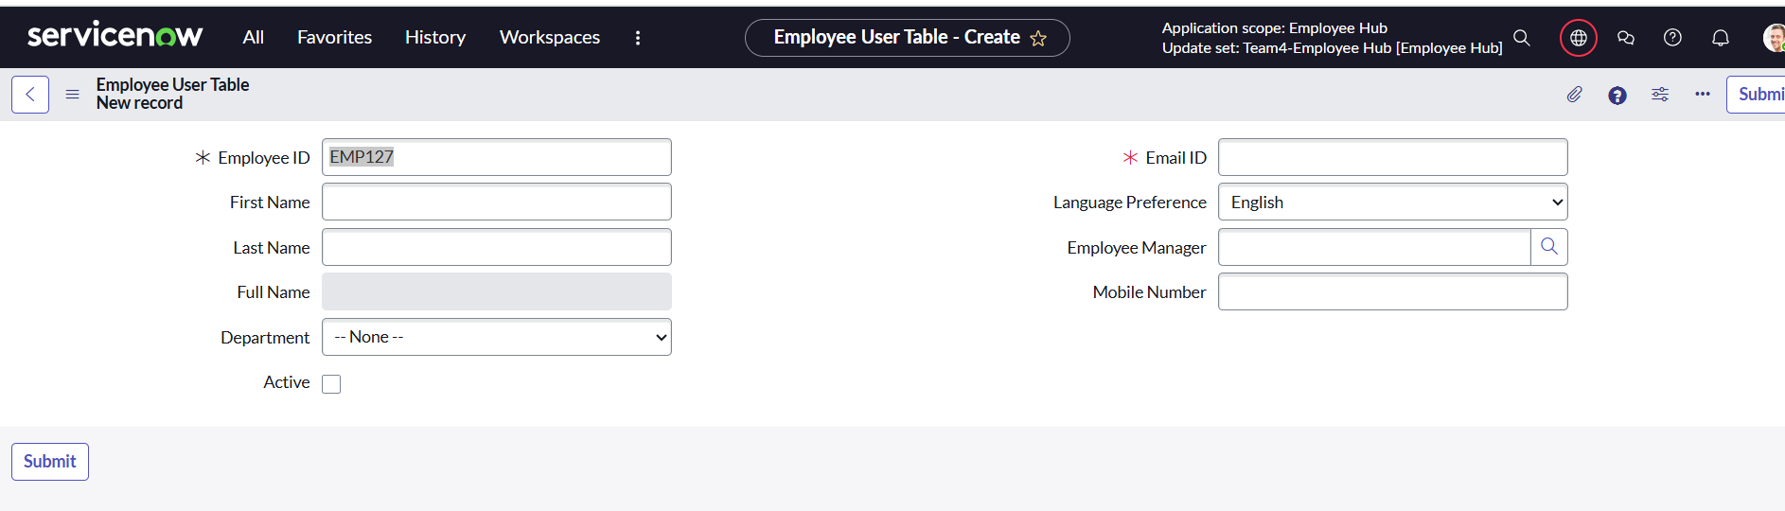Note: We have used the Read Only/Mandatory fields in the Form builder instead of creating separate UI policies.

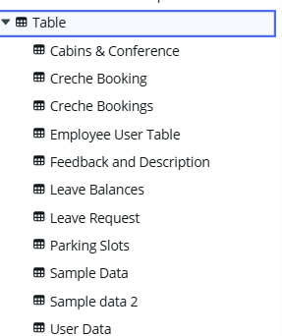

# **Milestone 3: Client scripts and UI policy**

**Client Scripts** are used to run custom JavaScript code in the user’s browser, allowing you to dynamically control form behavior, field values, and UI interactions in real time. They help in validating data, making fields mandatory, hiding or displaying fields, and improving user experience without a server call.

**UI Policies** are rule-based configurations that let you dynamically change form appearance and behavior without scripting. They are commonly used to make fields mandatory, read-only, or visible based on conditions, making them simpler and easier to maintain compared to client scripts.  
  
We have used the Read Only/Mandatory fields in the Form builder instead of creating separate UI policies.

## **Activity 1: Client Script for Creche Bookings table (Onsubmit) Navigate** to *System Definition > Client Scripts* in ServiceNow.

* **Click New** to create a new client script.
* **Fill in the details**:
  + **Name**: Creche Booking Confirmed
  + **Table**: [x_cdltd_employee_h_creche_table]
  + **UI Type**: Desktop
  + **Type**: onSubmit (so the script runs when a user click Submit, Save, or Update on a form before the record is sent to the server)
* **Set Active and Global** to checked (enabled).
* **Add the script** in the *Script* field:

function onSubmit() {

   //Type appropriate comment here, and begin script

   g_form.addInfoMessage("Your Booking is Confirmed!");

}

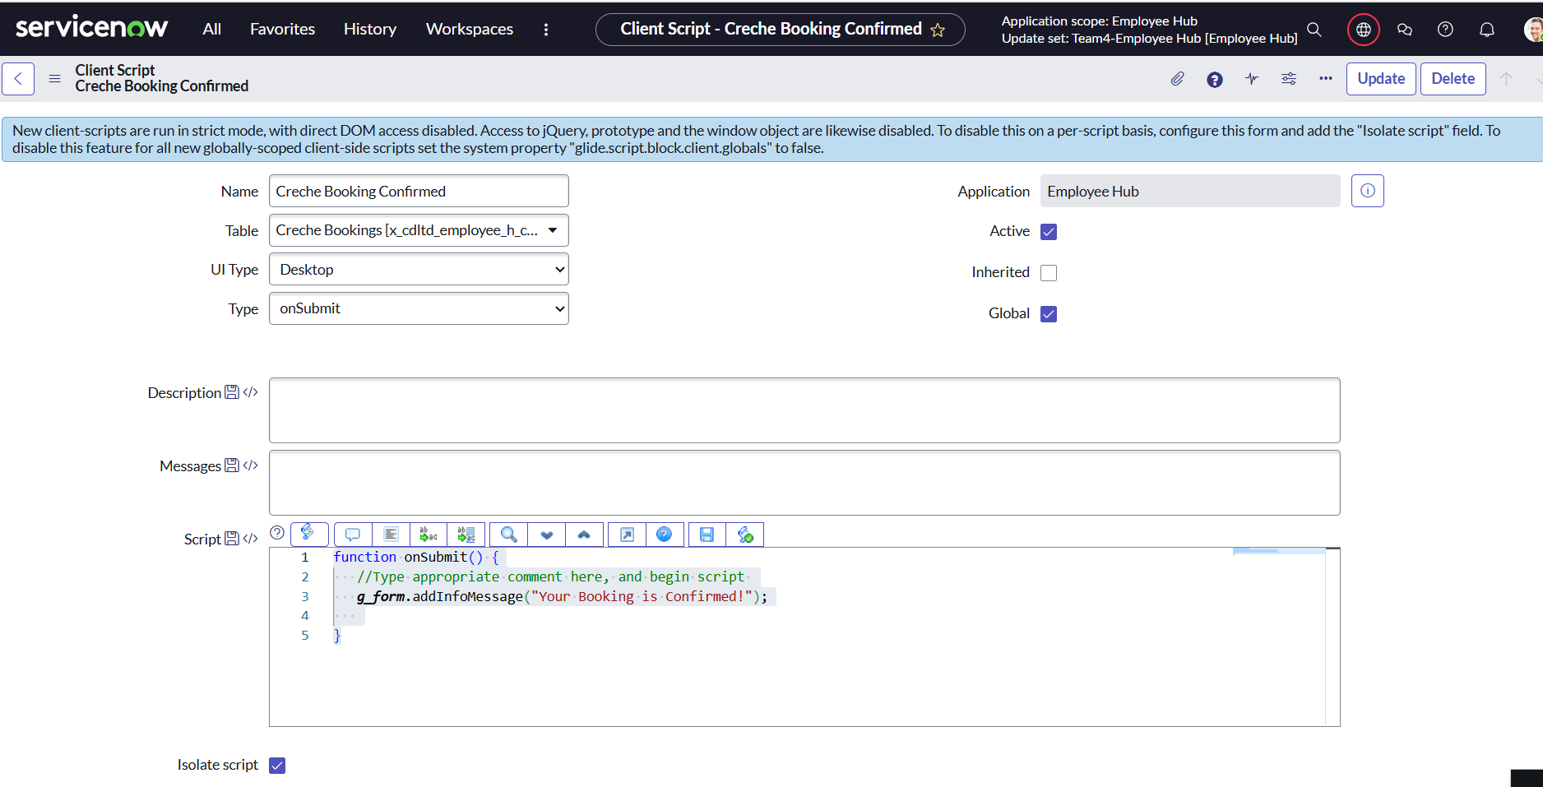

## **Activity 2: Client script for Creche Bookings (OnLoad)**

1. Go to **System Definition > Client Scripts**.

2. Click **New**.

3. Fill in the fields:

* + **Name**: Booking Date availbility in creche book
  + **Table**: [x_cdltd_employee_h_creche_table]
  + **UI Type**: Desktop
  + **Type**: onLoad(that runs in the browser when a form loads.)
  + **Active**: checked
  + **Global**: ️checked

Add the script in the **Script** field:

1. function onLoad() {
2. // Today at midnight
3. var today = new Date();
4. today.setHours(0, 0, 0, 0);
5. // Tomorrow
6. var tomorrow = new Date(today);
7. tomorrow.setDate(tomorrow.getDate() + 1);//Type appropriate comment here, and begin script below
8. function format(d) {
9. var yyyy = d.getFullYear();
10. var mm = ('0' + (d.getMonth() + 1)).slice(-2);
11. var dd = ('0' + d.getDate()).slice(-2);
12. return dd + '-' + mm + '-' + yyyy;
13. }
14. var minDate = format(today);
15. var maxDate = format(tomorrow);
16. var ctrl = g_form.getControl('booking_date'); // Date variable
17. if (ctrl) {
18. ctrl.setAttribute('min', minDate);
19. ctrl.setAttribute('max', maxDate);
20. }
21. }

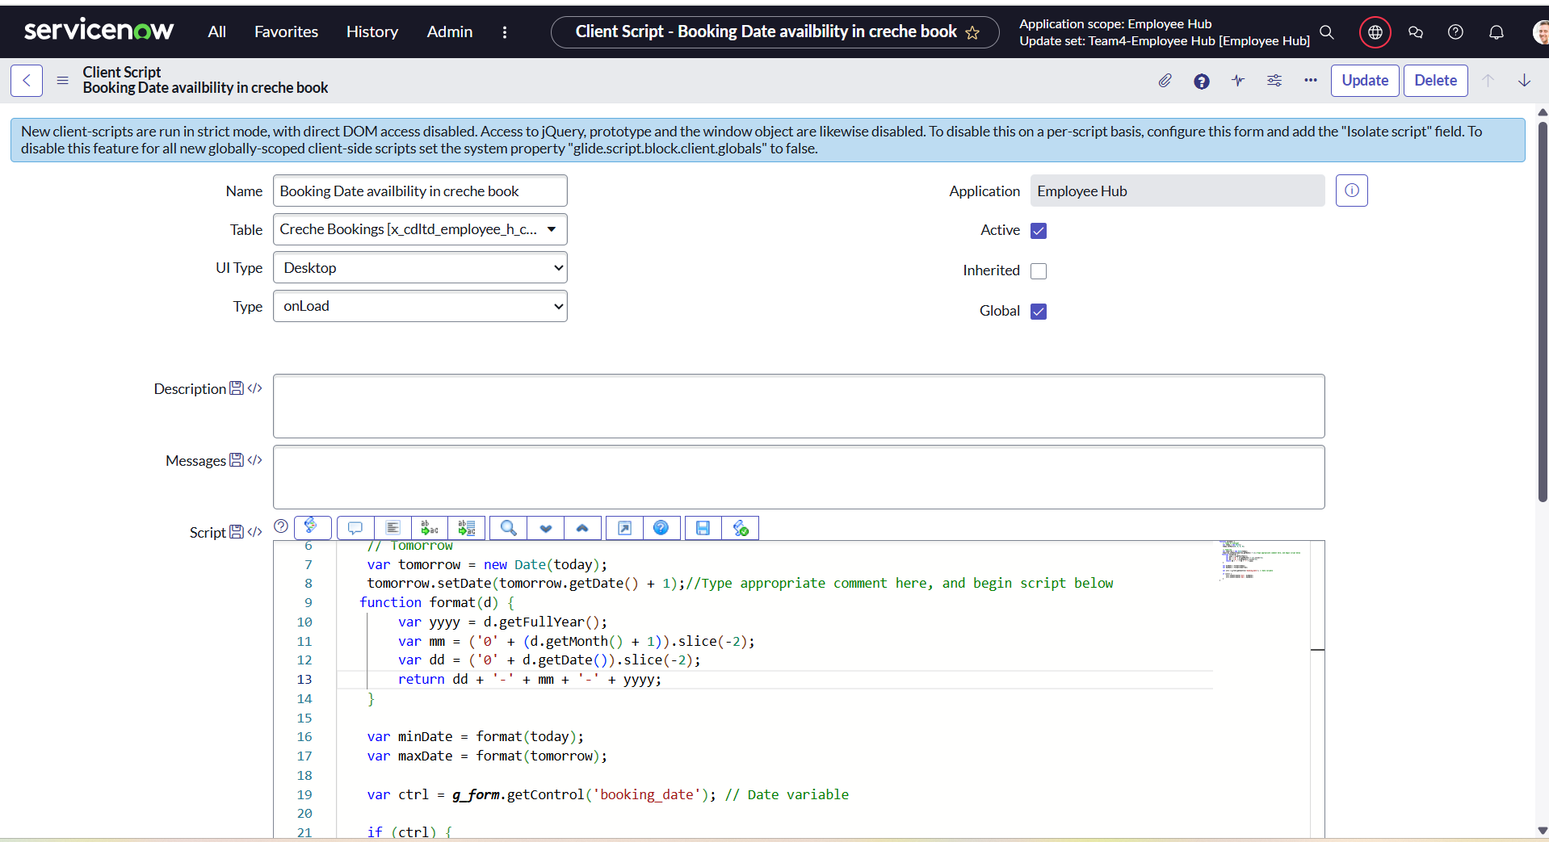

## **Activity 3: Client script for Parking slot table(onsubmit)**:

* **Navigate** to *System Definition > Client Scripts* in ServiceNow.
* **Click New** to create a new client script.
* **Fill in the details**:
  + **Name**: Form Submit
  + **Table**: [x_cdltd_employee_h_parking_slots]
  + **UI Type**: All
  + **Type**: onSubmit (so the script runs when a user click Submit, Save, or Update on a form before the record is sent to the server)
* **Set Active and Global** to checked (enabled).
* **Add the script** in the *Script* field:

function onSubmit() {

    //Type appropriate comment here, and begin script below

    g_form.setValue('booking_confirmation', 'Confirmed');

}

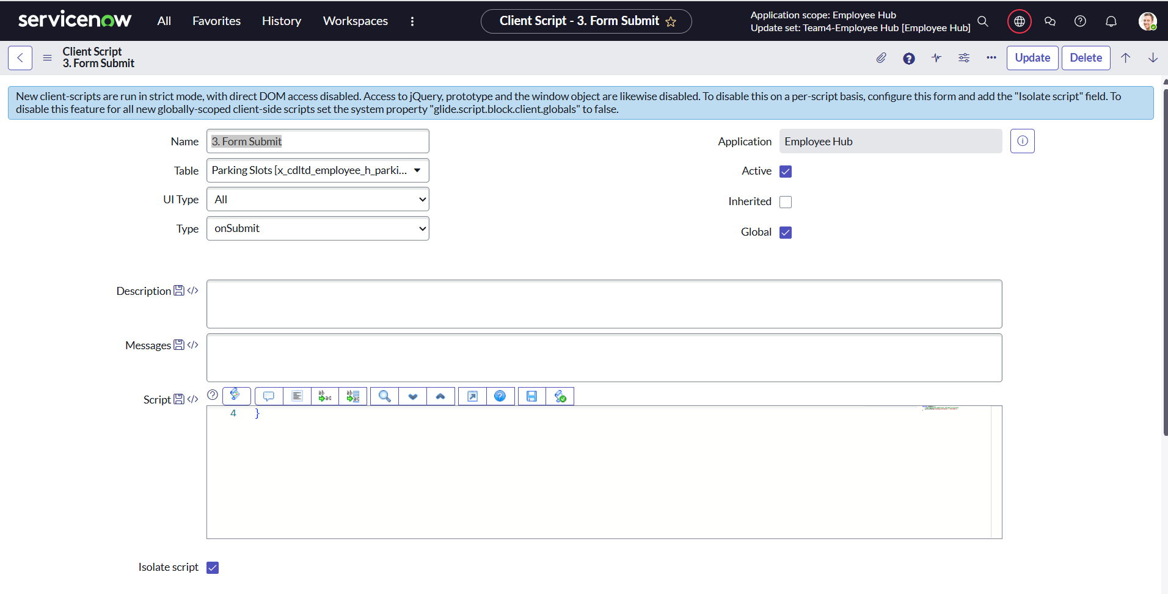

## **Activity 4: Client script for Parking slot table** (**OnChange**)

* **Navigate** to *System Definition > Client Scripts* in ServiceNow.
* **Click New** to create a new client script.
* **Fill in the details**:
  + **Name**: Occupancy
  + **Table**:  [x_cdltd_employee_h_parking_slots]
  + **UI Type**: All
  + **Type**: onChange (so the script runs when a specific field value changes)
* **Set Active and Global** to checked (enabled).
* **Add the script** in the *Script* field:

function onChange(control, oldValue, newValue, isLoading, isTemplate) {

    if (isLoading || newValue === '') {

        return;

    }

    // If active is false → set occupancy = Occupied

    if (newValue === 'Confirmed') {

        g_form.setValue('occupancy', 'Occupied');

    }

}

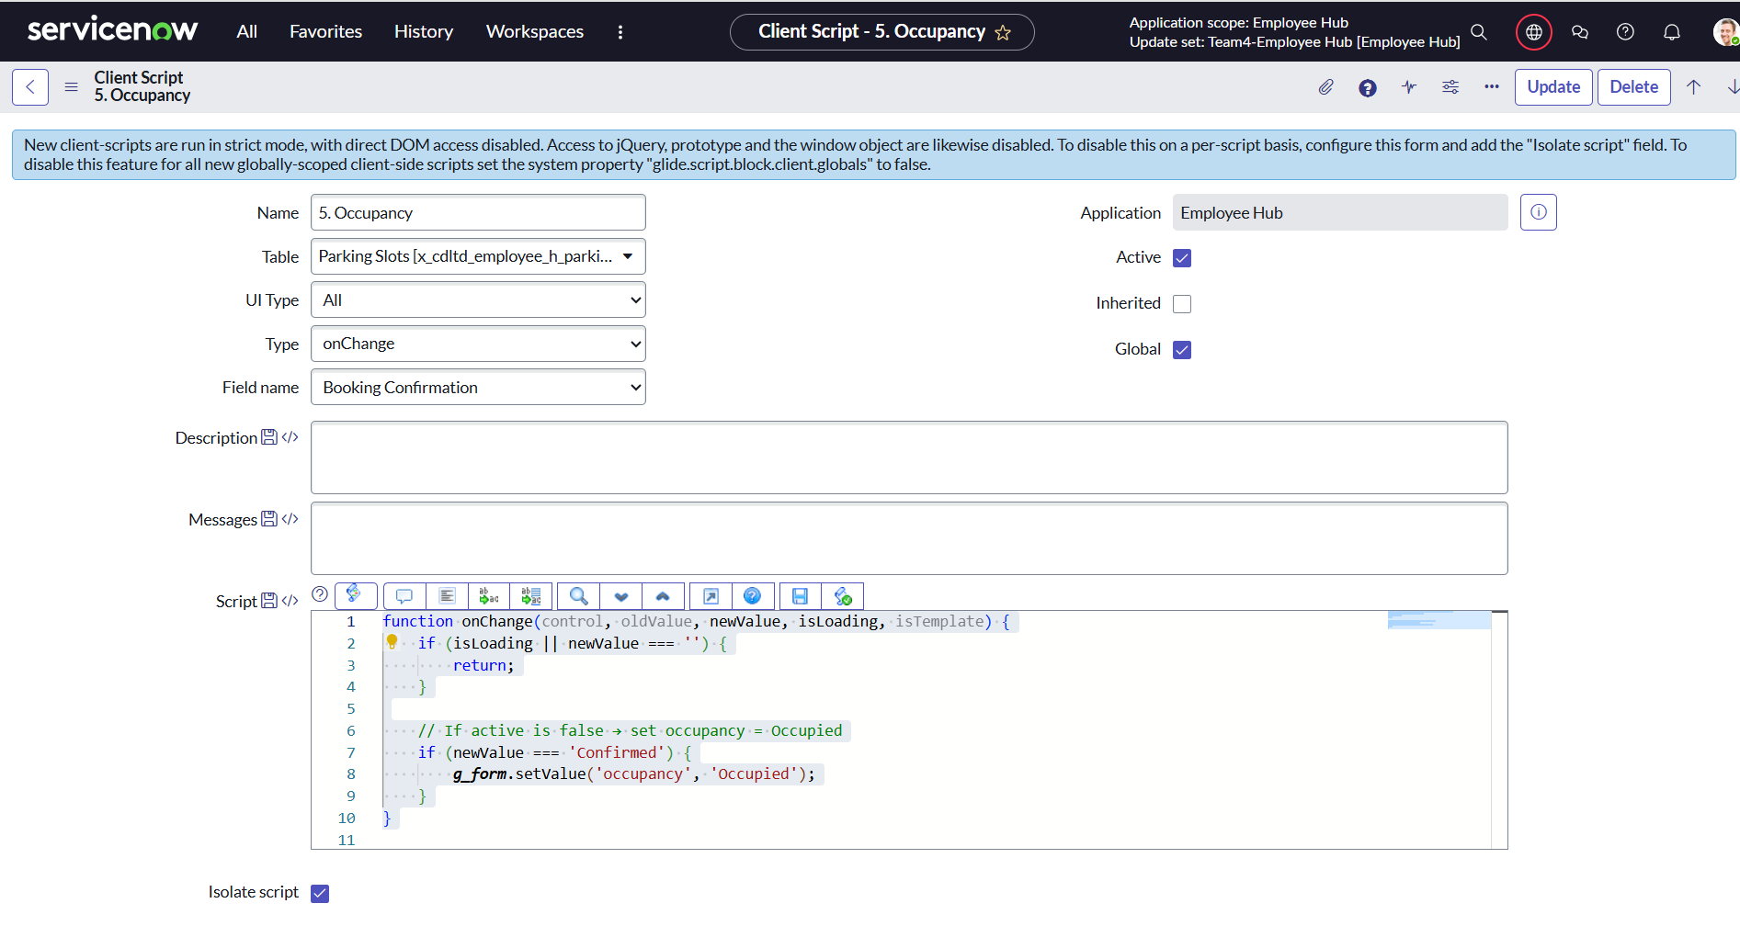

## **Activity 5: Client script for Parking slot table (Onsubmit)**:

* **Navigate** to *System Definition > Client Scripts* in ServiceNow.
* **Click New** to create a new client script.
* **Fill in the details**:
  + **Name**: Active False
  + **Table**:  [x_cdltd_employee_h_parking_slots]
  + **UI Type**: All
  + **Type**: OnSubmit (so the script runs when a user clicks Submit, Save, or Update on a form before the record is sent to the server)
* **Set Active and Global** to checked (enabled).
* **Add the script** in the *Script* field:

function onSubmit() {

    //Type appropriate comment here, and begin script below

    if (g_form.getValue('booking_confirmation') == 'Confirmed! || Confirmed') {

        g_form.setValue('active', false);

    }

}

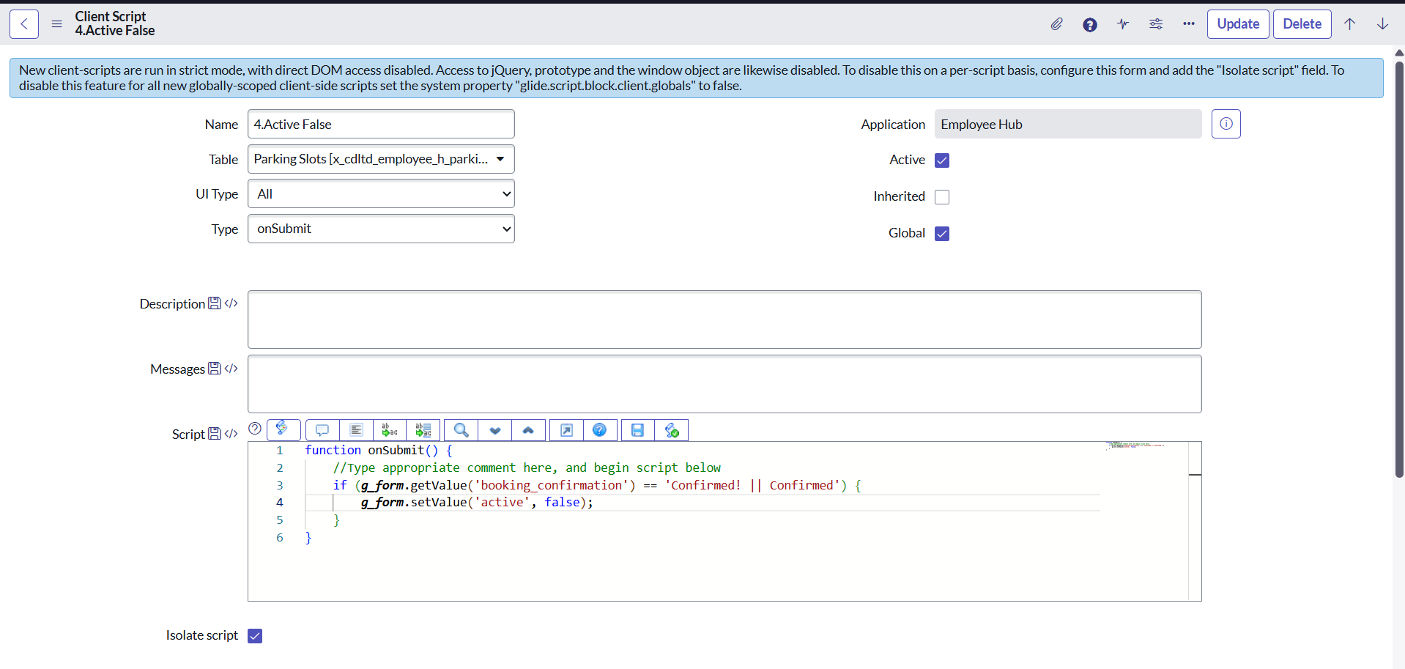

## **Activity 6: Client script for Cabin & conference table (OnLoad)**:

* **Navigate** to *System Definition > Client Scripts* in ServiceNow.
* **Click New** to create a new client script.
* **Fill in the details**:
  + **Name**: Form_Load
  + **Table**:  [x_cdltd_employee_h_cabins_conference]
  + **UI Type**: ALL
  + **Type**: onLoad(that runs in the browser when a form loads.)
* **Set Active and Global** to checked (enabled).
* **Add the script** in the *Script* field:

1. function onLoad() {
2. //Type appropriate comment here, and begin script below
3. g_form.setDisplay("conference_room_name",false);
4. g_form.setDisplay("date",false);
5. g_form.setDisplay("capacity",false);
6. g_form.setDisplay("cabin_number",false);
7. g_form.setDisplay("floor",false);
8. g_form.setDisplay("from_time",false);
9. g_form.setDisplay("end_time",false);
10. }

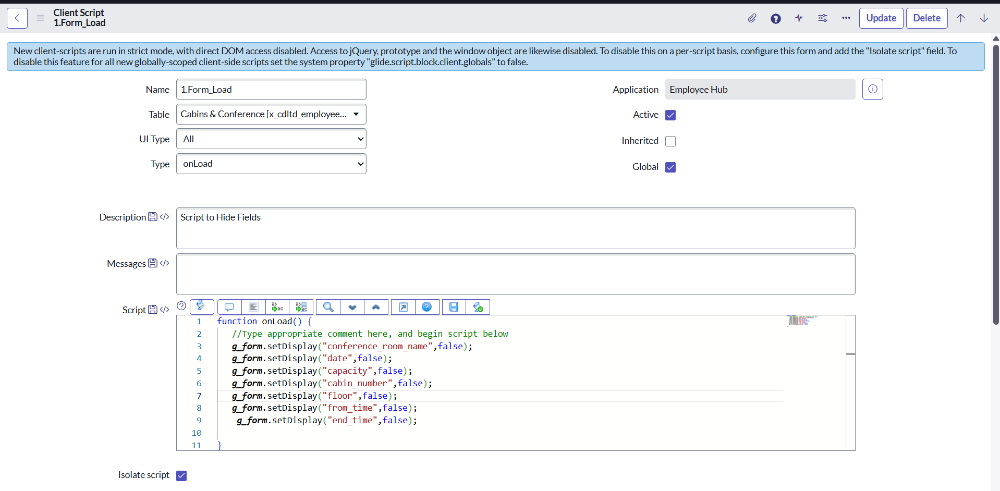

## **Activity 7: Client script for Cabin & conference table (OnChange)**:

* **Navigate** to *System Definition > Client Scripts* in ServiceNow.
* **Click New** to create a new client script.
* **Fill in the details**:
  + **Name**: Type Field
  + **Table**: [x_cdltd_employee_h_cabins_conference]
  + **UI Type**: All
  + **Field Name**: Type
* **Type**: OnChange (so the script runs when a specific field value changes)
* **Set Active and Global** to checked (enabled).
* **Add the script** in the *Script* field:

1. function onChange(control, oldValue, newValue, isLoading, isTemplate) {
2. if (isLoading || newValue === '') {
3. return;
4. }
5. if(newValue == "Cabin")
6. {
7. g_form.setDisplay("cabin_number",true);
8. g_form.setDisplay("floor",true);
9. g_form.setDisplay("conference_room_name",false);
10. g_form.setDisplay("capacity",false);
11. g_form.setDisplay("from_time",false);
12. g_form.setDisplay("end_time",false);
13. g_form.setDisplay("date",true);
14. }
15. else if(newValue == "Conference Room")
16. {
17. g_form.setDisplay("floor",true);
18. g_form.setDisplay("conference_room_name",true);
19. g_form.setDisplay("capacity",true);
20. g_form.setDisplay("cabin_number",false);
21. g_form.setDisplay("from_time",true);
22. g_form.setDisplay("end_time",true);
23. g_form.setDisplay("date",true);
24. }
25. //Type appropriate comment here, and begin script below
26. }

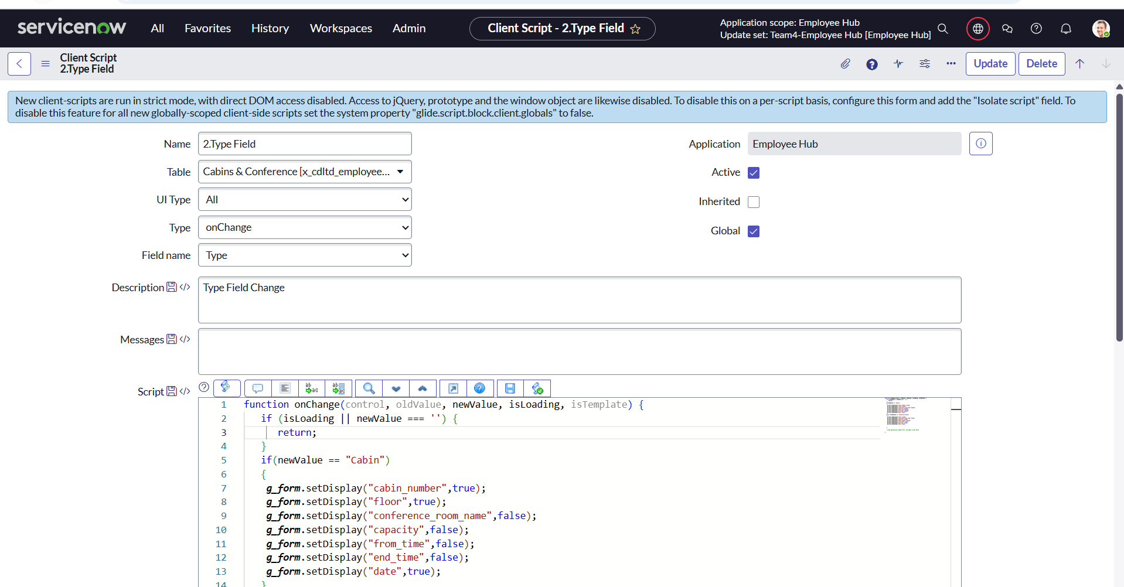

**UI Policy:**

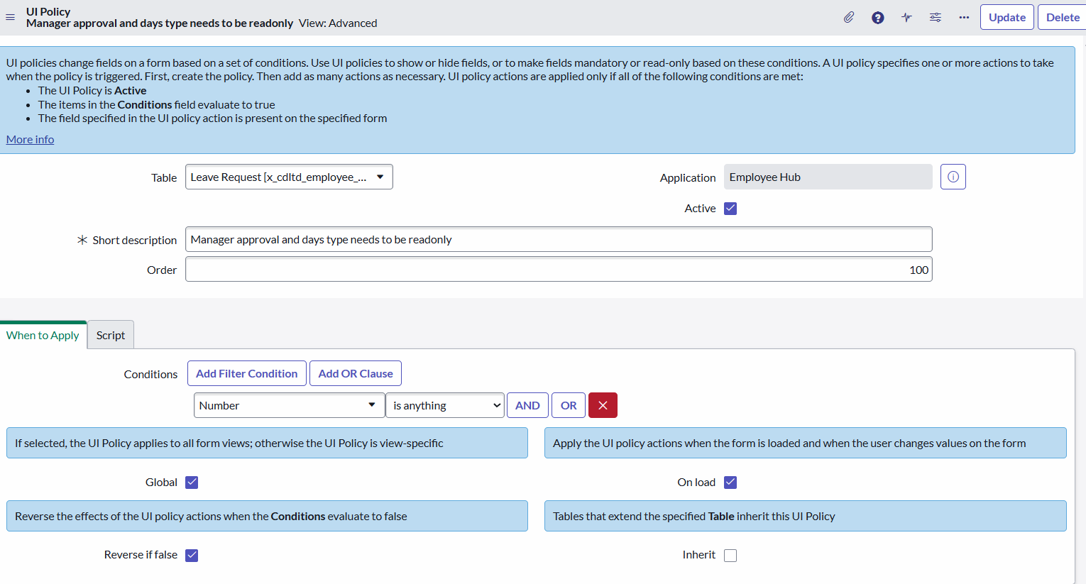

# **Milestone 4: Business Rules**

A Business Rule is a server-side script that runs on database operations (insert, update, delete, query) to enforce business logic and automate processes in ServiceNow.

* Business Rule Logic
  + Caretaker Name & Contact number assignment  
     When a new booking request is created the Caretaker name option is provided while creating a creche booking.
    - When the Age Group is selected, the Caretaker name & Contact number will be autopopulated in the field based on the age group of the child.

## **Activity1: Adding Business Rules**

1. Navigate to Business Rules Section

* In the ServiceNow application navigator, type:

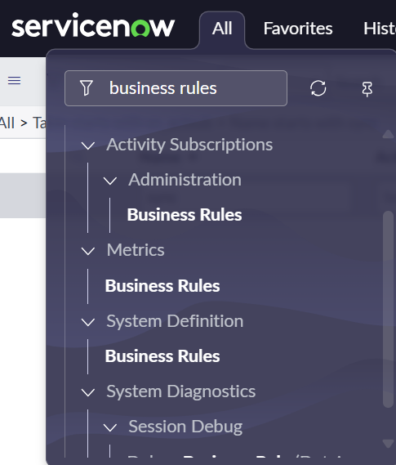

* Click Business Rules under System Definition.

2. Create a New Business Rule

* Click New to create a new Business Rule.

3. Fill in Business Rule Details

|  |  |
| --- | --- |
| Name | Autofill caretaker name by age |
| Application | Employee Hub |
| Table | x_cdltd_employee_h_creche_table |
| Active | Checked |
| Advanced | Checked |

4️. Define When the Business Rule Should Run

In the When to run tab:

|  |  |
| --- | --- |
| When | before |
| Insert | Checked |
| Update | Unchecked |
| Delete | Unchecked |
| Query | Unchecked |
| Order | 10 |

* **Add the script** in the *Script* field:

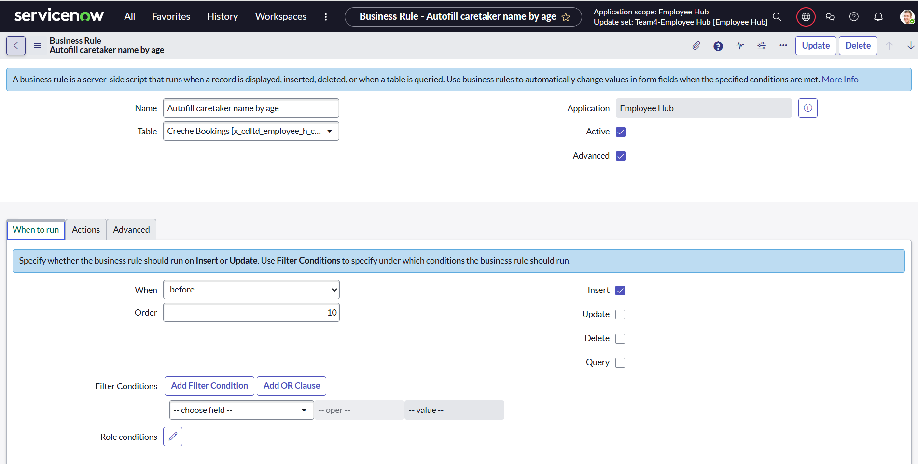

(function executeRule(current, previous /*null when async*/ ) {

    // Add your code here

    if (current.age_group == '3_6_months') {

        current.setValue('caretaker_name', 'divya');

    } else if (current.age_group == '6_1_years') {

        current.setValue('caretaker_name', 'pranali');

    } else {

        current.setValue('caretaker_name', 'tejaswi');

    }

})(current, previous);

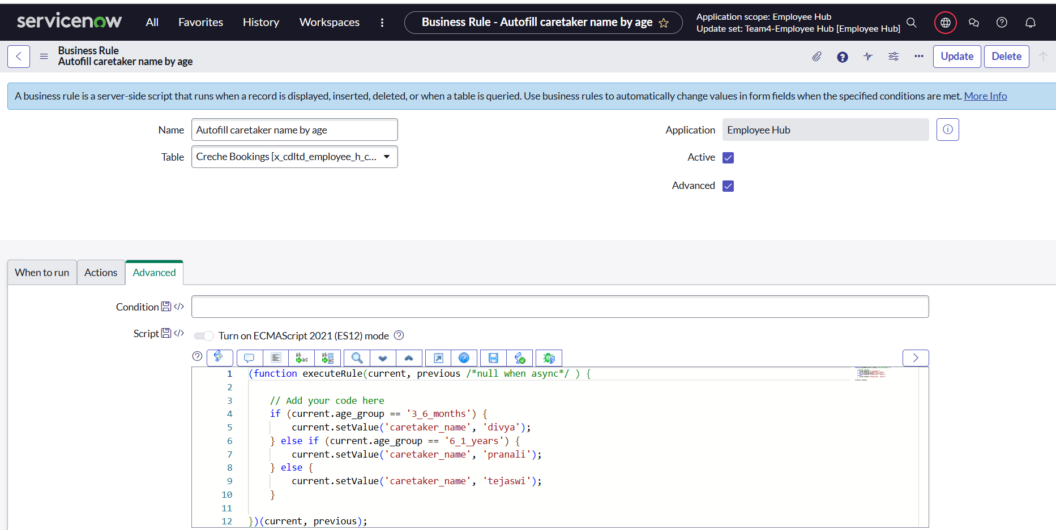

No Filter Conditions or Role Conditions needed in this case.

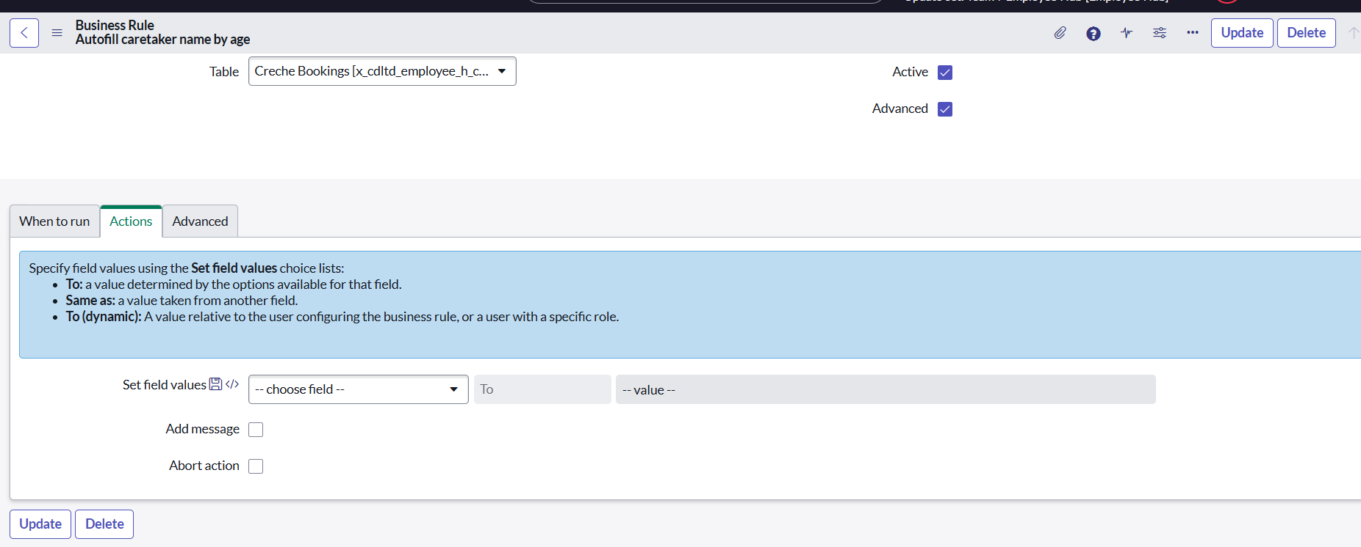  
6. Save the Business Rule

* Click Submit or Update to save the Business Rule.

7.Test the Business Rule

* + 1. When the Age Group is selected, the Caretaker name & Contact number should be autopopulated in the field based on the age group of the child.

**In the same way we have created some more business rules:**

## **Activity 2: Cabin & Conference Booking**

1. Navigate to Business Rules Section

* In the ServiceNow application navigator, type:



* Click Business Rules under System Definition.

2. Create a New Business Rule

* Click New to create a new Business Rule.

3. Fill in Business Rule Details

|  |  |
| --- | --- |
| Name | Before user Insert |
| Application | Employee Hub |
| Table | [x_cdltd_employee_h_cabins_conference] |
| Active | Checked |
| Advanced | Checked |

4.Define When the Business Rule Should Run

In the When to run tab:

|  |  |
| --- | --- |
| Field | Value |
| When | before |
| Insert | Checked |
| Update | Unchecked |
| Delete | Unchecked |
| Query | Unchecked |
| Order | 100 |

**5.Add the script** in the *Script* field:

(function executeRule(current, previous /*null when async*/ ) {

    // Add your code here

    if(!current.username)

    {

        current.username = gs.getUser().getDisplayName();

    }

})(current, previous);

No Filter Conditions or Role Conditions needed in this case.

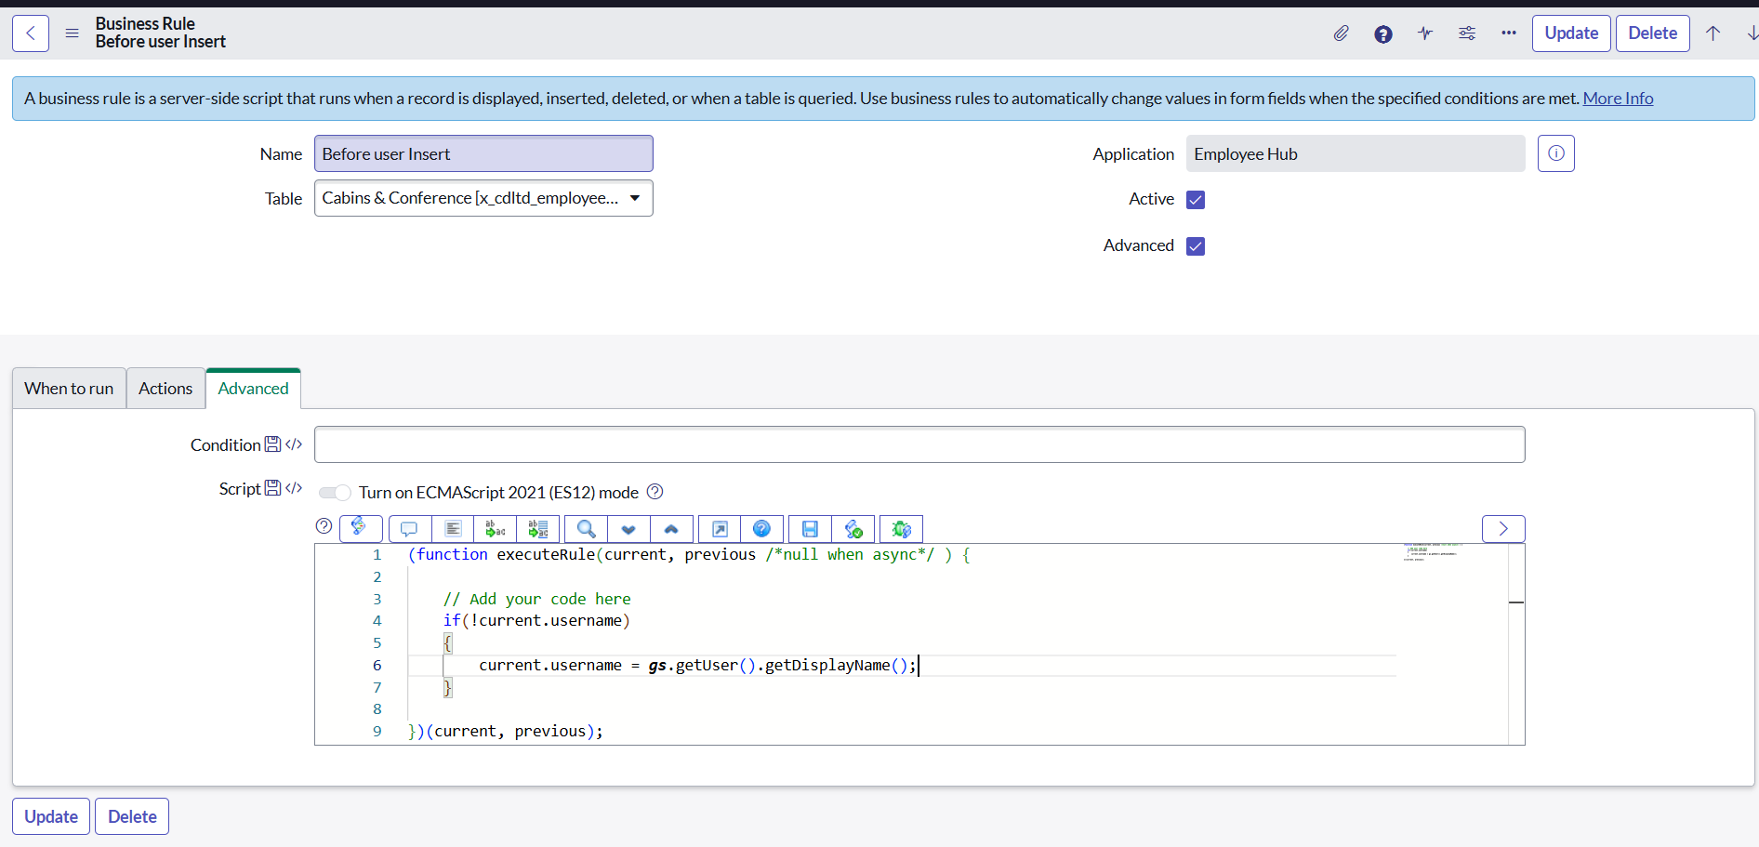

## **Activity 3: For Parking Booking**

1. Navigate to Business Rules Section

In the ServiceNow application navigator, type:



* Click Business Rules under System Definition.

2. Create a New Business Rule

* Click New to create a new Business Rule.

3. Fill in Business Rule Details

|  |  |
| --- | --- |
| Name | Before user Insert_parking |
| Application | Employee Hub |
| Table | Parking Slots [x_cdltd_employee_h_parking_slots] |
| Active | Checked |
| Advanced | Checked |

4.Define When the Business Rule Should Run

In the When to run tab:

|  |  |
| --- | --- |
| When | before |
| Insert | Checked |
| Update | Unchecked |
| Delete | Unchecked |
| Query | Unchecked |
| Order | 100 |

* **Add the script** in the *Script* field:

(function executeRule(current, previous /*null when async*/ ) {

    // Add your code here

    if(!current.employee_id)

    {

        current.employee_id = gs.getUser().getDisplayName();

    }

})(current, previous);

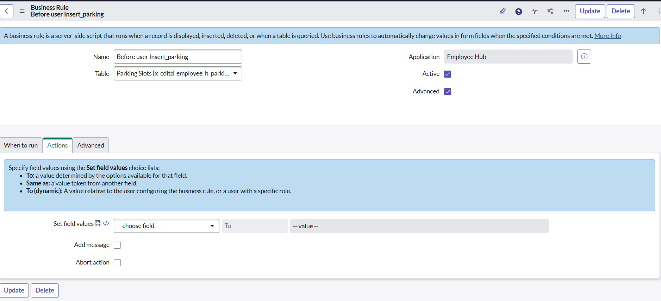

* **Table Targeted**  
   The Business Rule is applied to the Employee user table, Creche bookings, parking slots, cabin & conference rooms where records are created or updated.
* **Trigger Condition**  
   This is an **Advanced Business Rule** set to execute every time a record is inserted or updated.

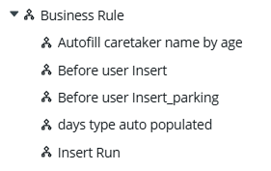

## **Workflow:**

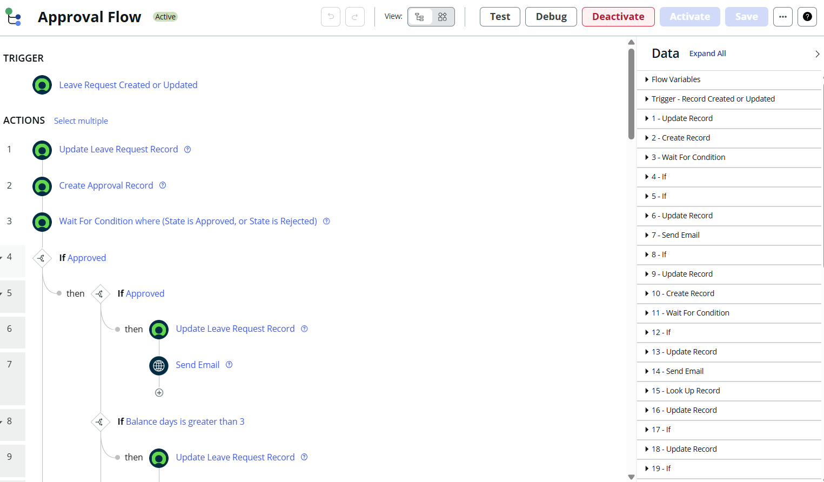

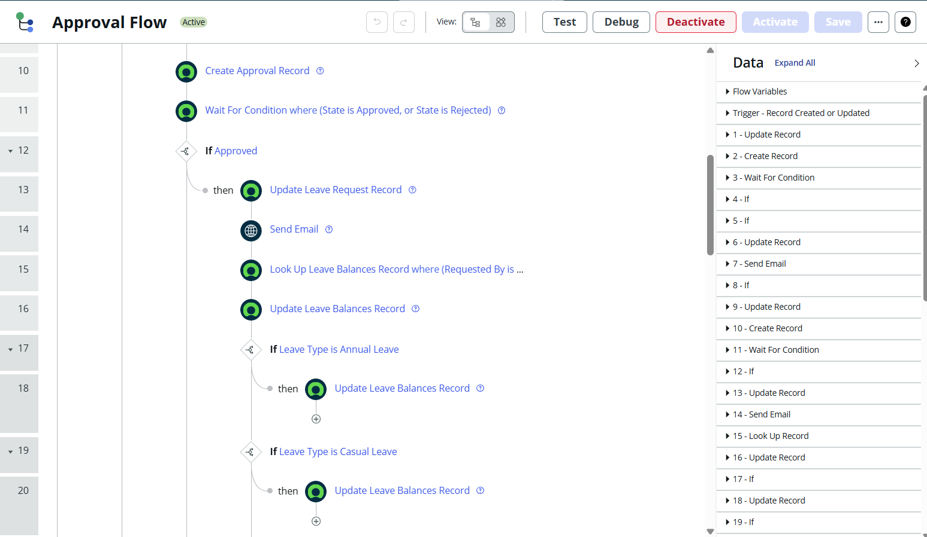

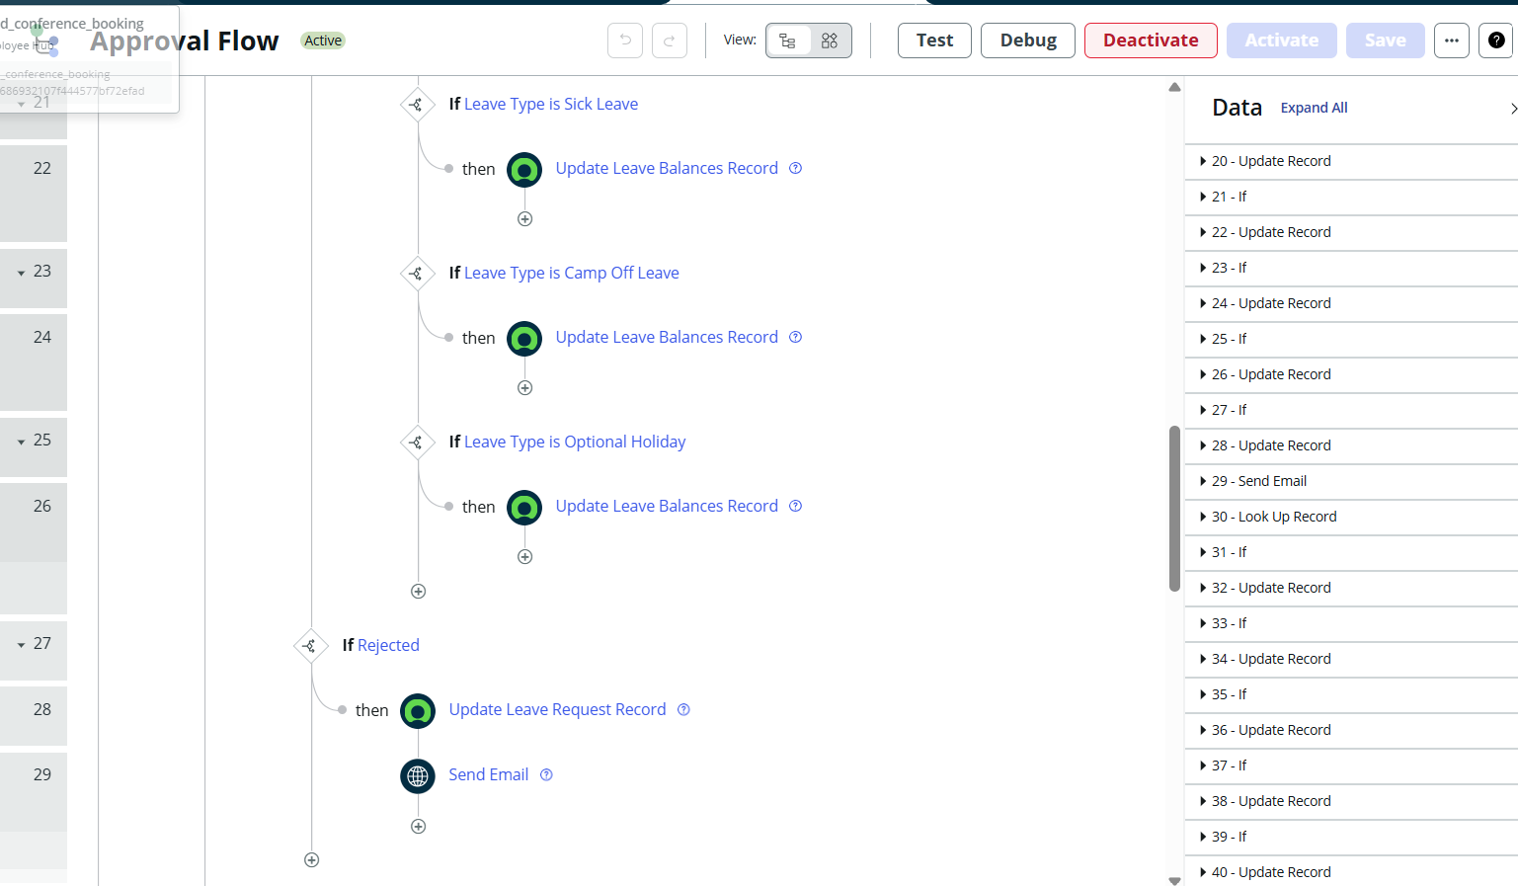

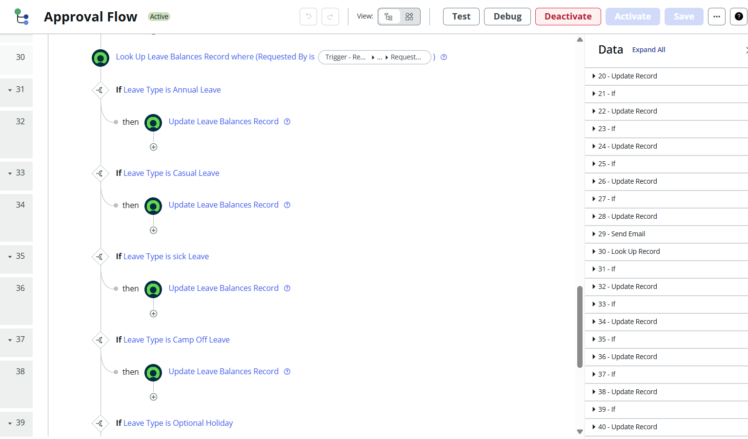

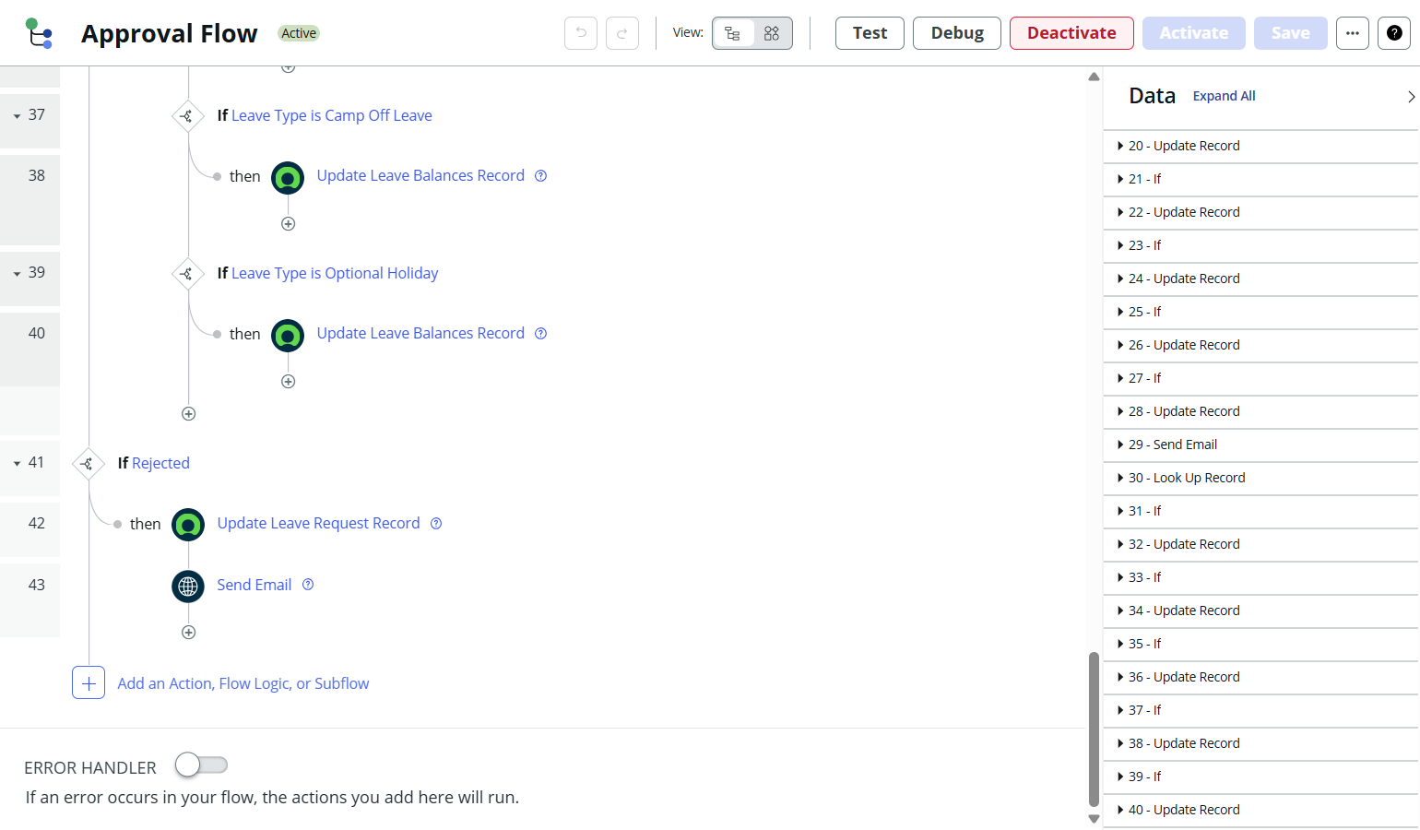

# **Milestone 5: Email Notification**

## **Activity:Steps to Create Notification**

Step 1: Navigate to Notifications

- Go to System Notification > Email > Notifications.

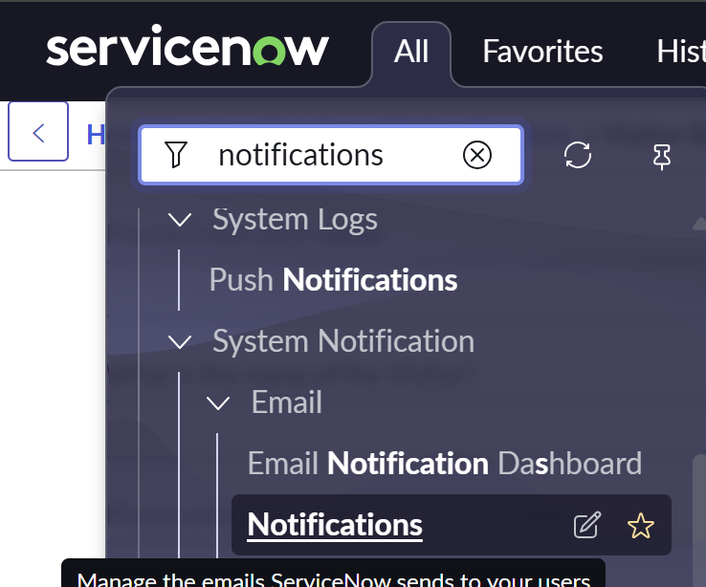

Step 2: Create New Notification

1. Click New.

2. Fill in the basic details:

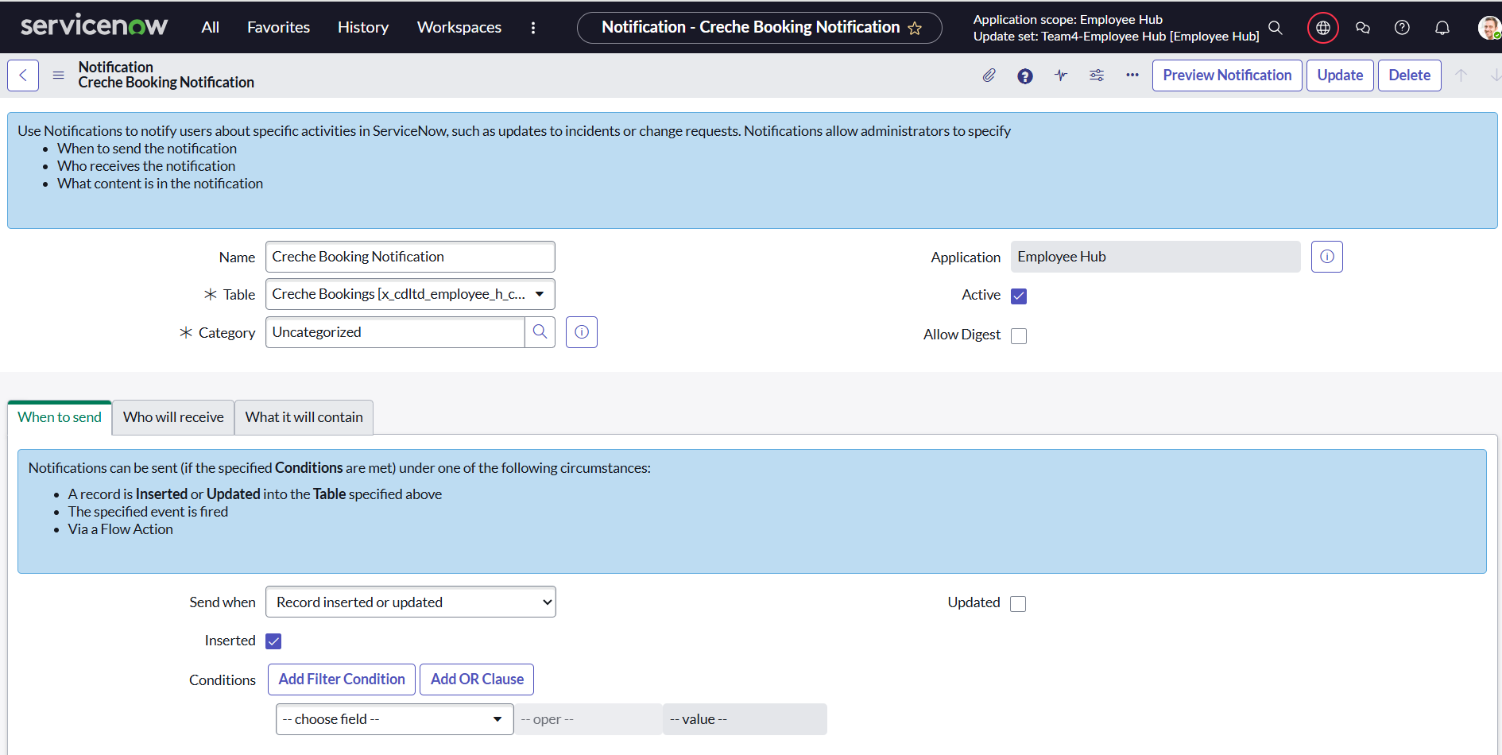

Step 3: Define When to Send

- Select Insert → This ensures the notification is triggered when a new record is inserted.

- Conditions (optional):

- For example, send only if Status = Active OR Email field is not empty.

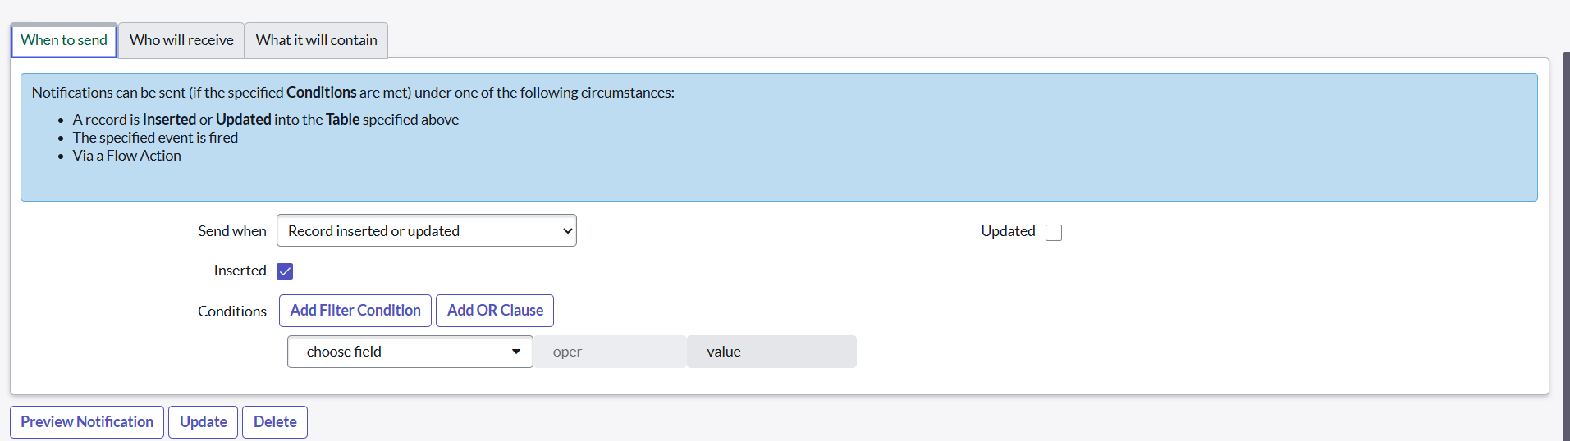

Step 4: Define Recipients

- Under Who will receive, select:

- Field → choose Email field from the Employee User table (so the receives the email).

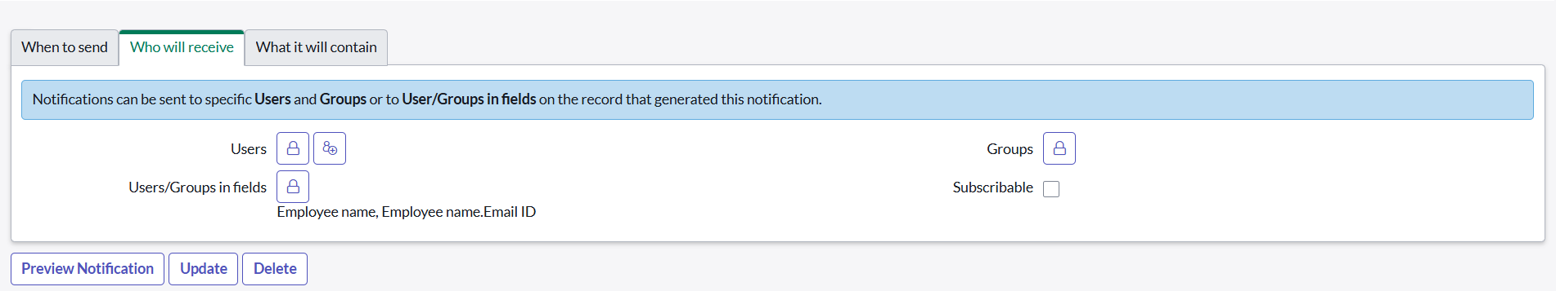

Step 5: **Define Email Content**

- Subject Line:

Hi  ${employee_name},

We reserved a creche for your little one!!

Creche Name: ${creche_name}

Care Taker Name: ${caretaker_name}

creche contact: ${creche_contact_number}

Your Child Name: ${child_name}

Will Take care of your little One! Happy Working.

We look forward to serving you. 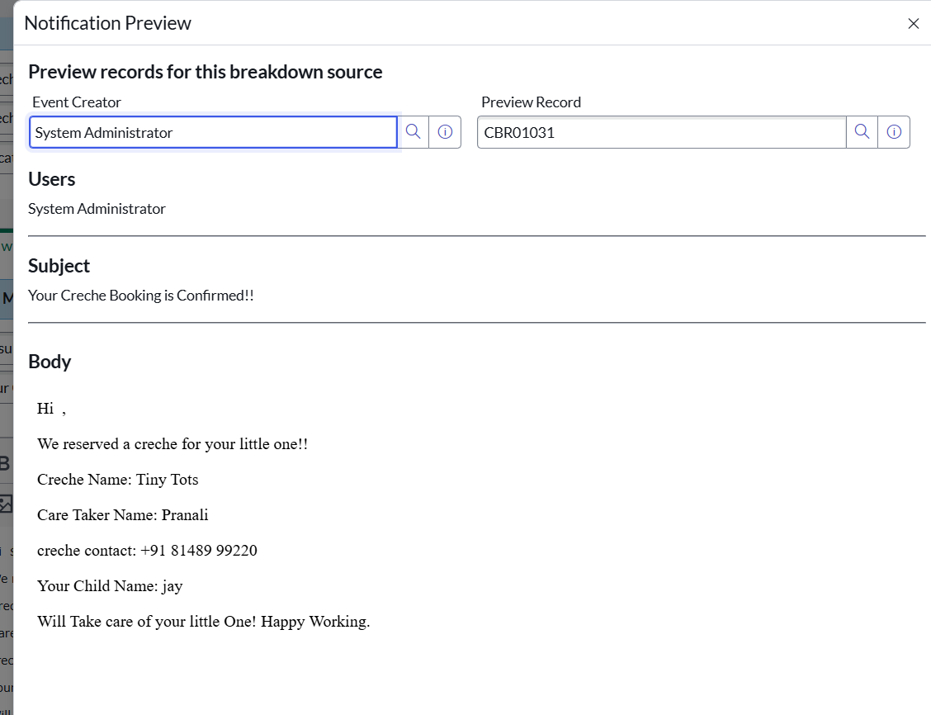

# **Notification 1: Creche Booking**

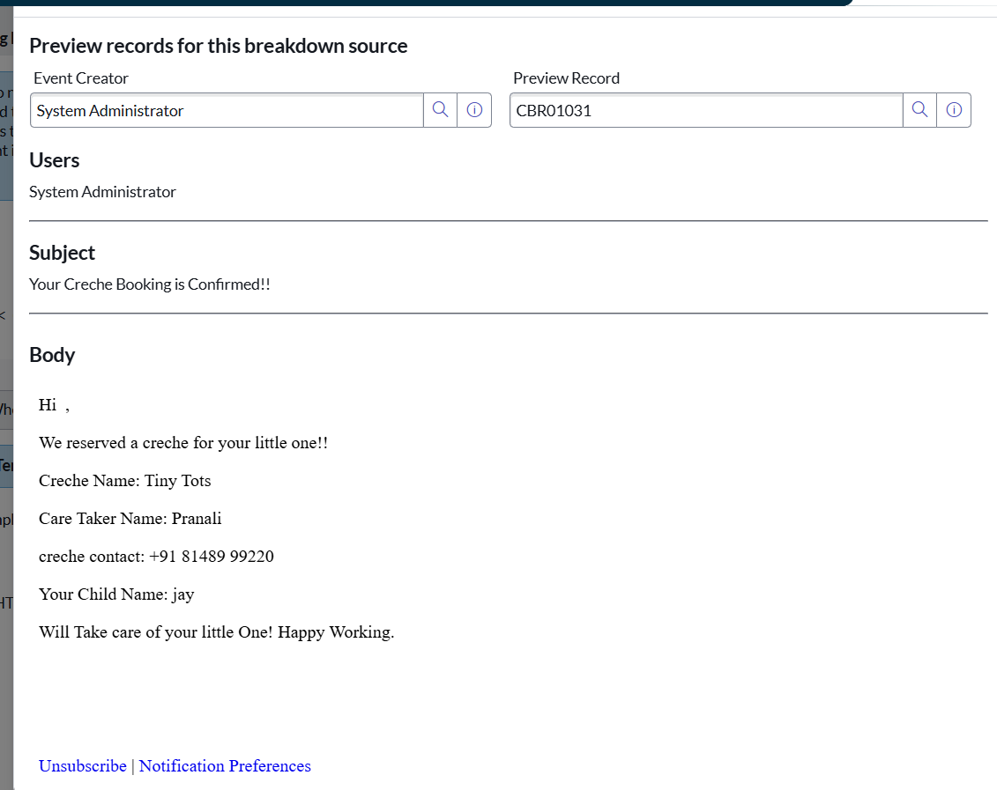

# **Notification 2: Cabin & Conference Booking**

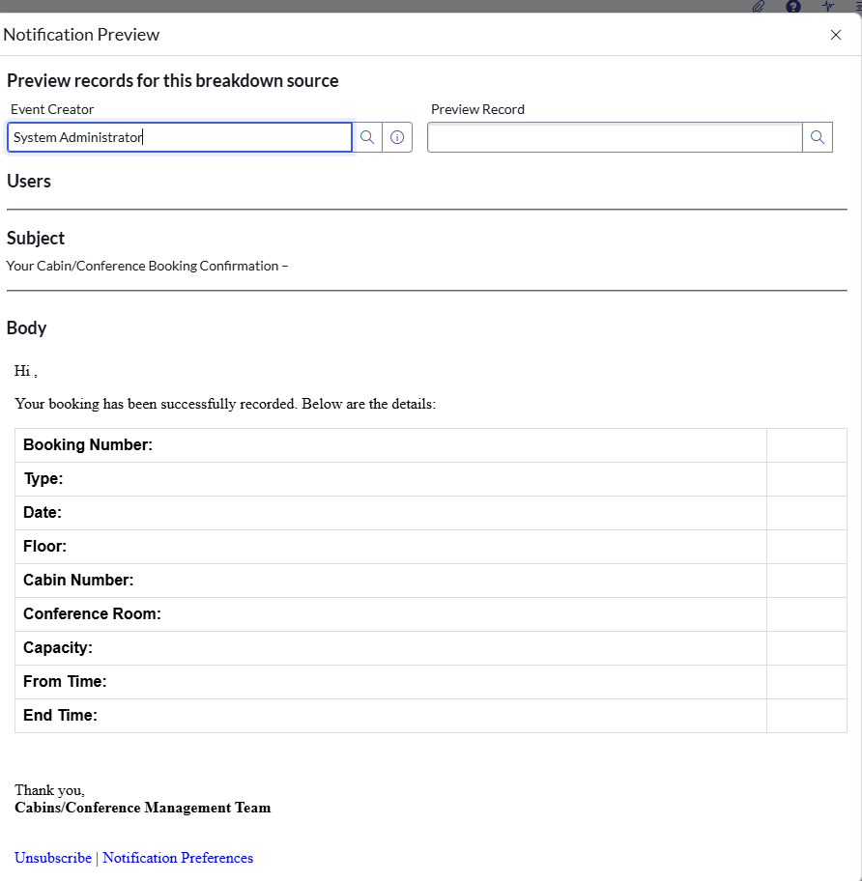

# **Notification 3: Parking slot Booking**

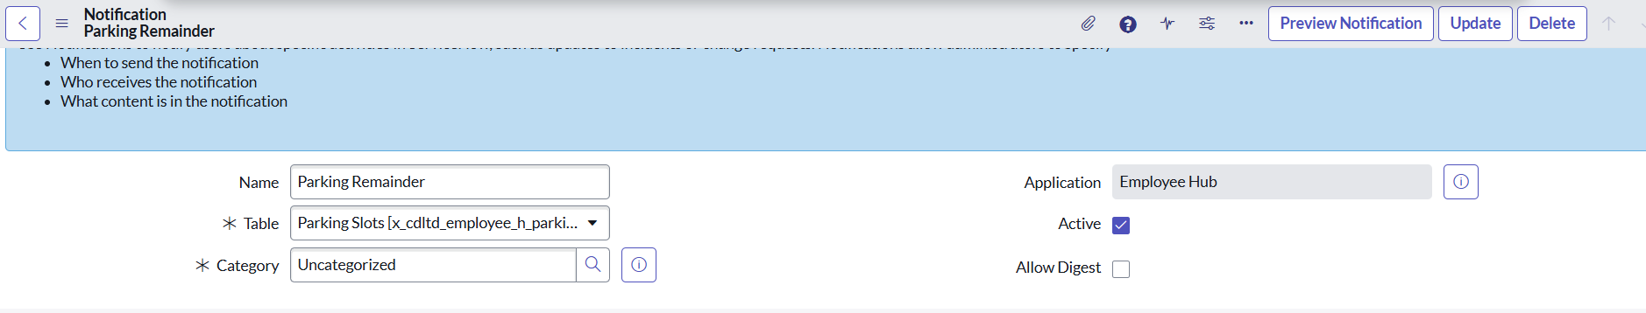

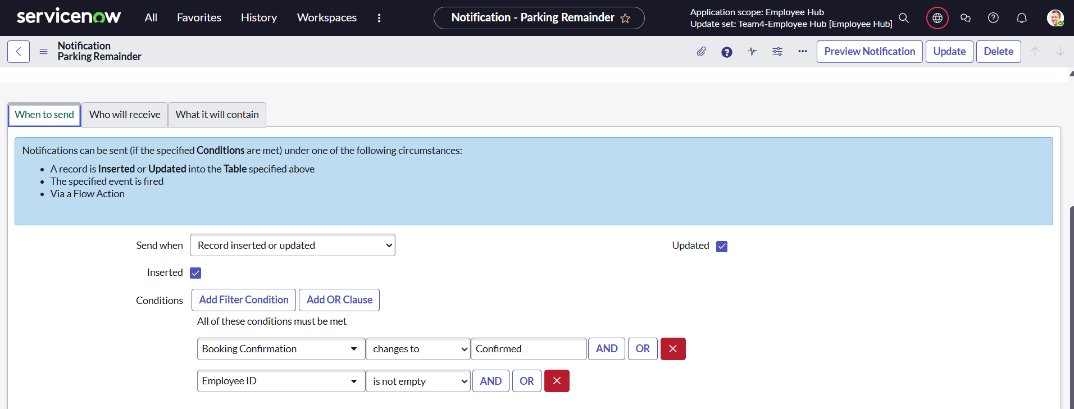

Parking Slot Booking Confirmation - ${booking_number}

Body:

Hi ${employee_id.name},

Your parking slot has been successfully booked. Below are your booking details:

|  |  |
| --- | --- |
| **Booking Number:** | ${booking_number} |
| **Vehicle Number:** | ${vehicle_number} |
| **Vehicle Type:** | ${vehicle_type} |
| **Slot Number:** | ${slot_number} |
| **Date:** | ${date} |
| **Booking Status:** | ${booking_confirmation} |
| **Occupancy:** | ${occupancy} |

Thank you,  
**Parking Management Team**

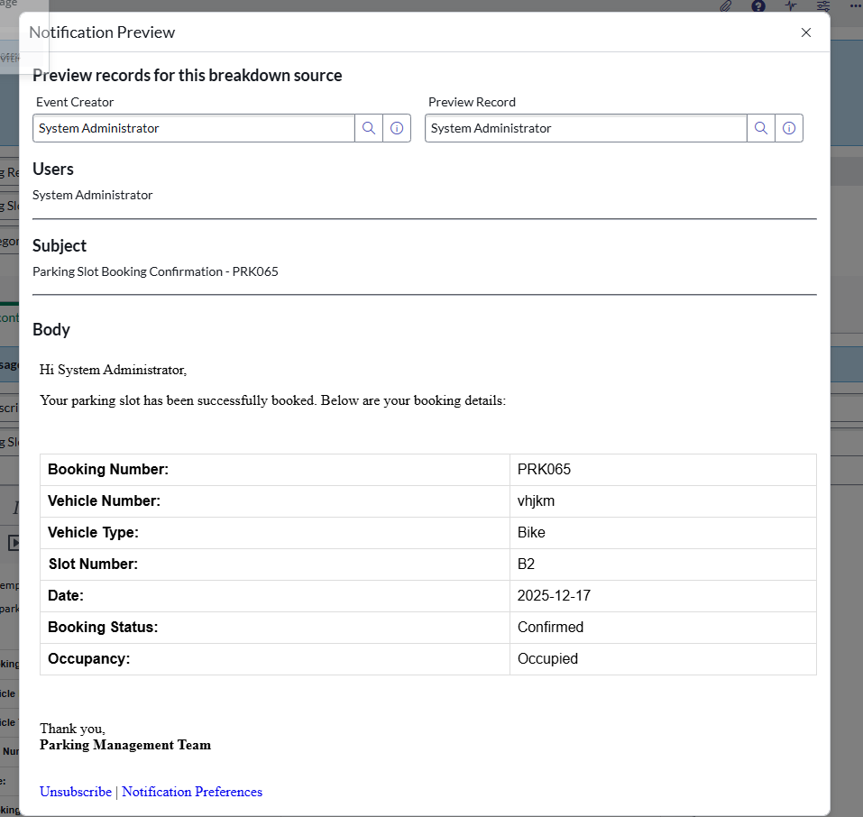

# **Milestone 6: Catalogs**

## **Catalog Item Creation**

Purpose: Catalog items represent individual services available in the catalog.

Steps Followed:

1. Navigate to: Service Catalog > Catalog Definitions > Maintain Items.

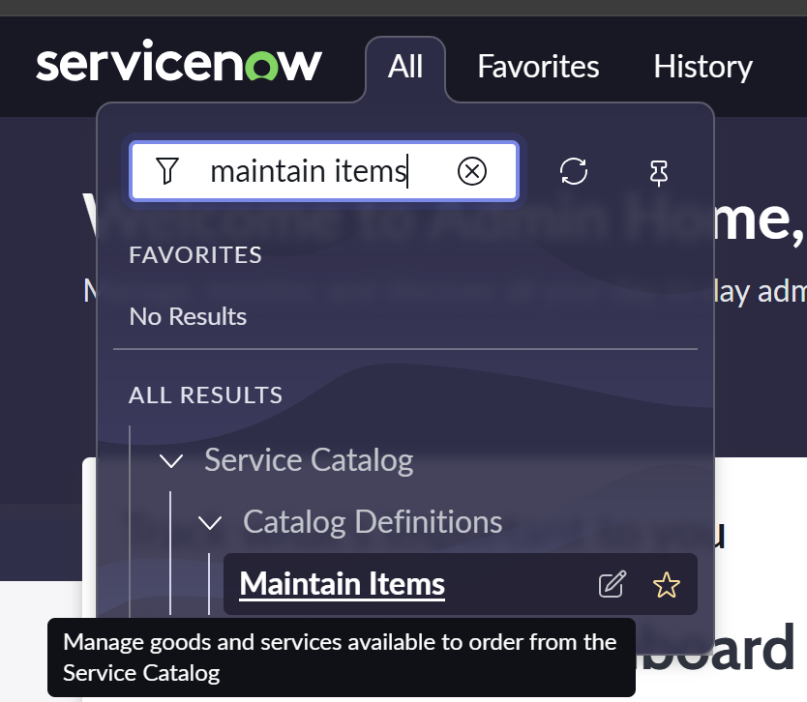

2. Click New.

3. Fill in the details:

- Name: Example – Creche Booking

- Description: Slot booking available

- Active: Checked

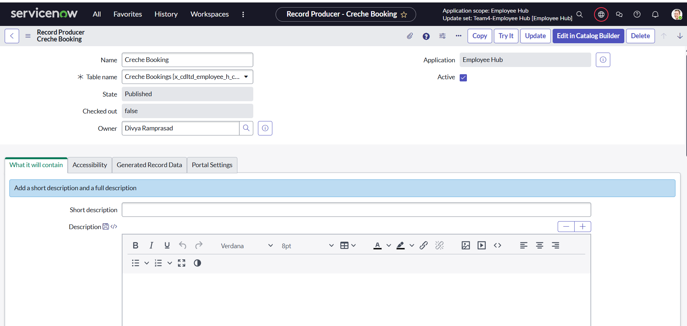

4. Add Variables for collecting input, such as:

- [Slots Available](https://ind-nov-5453-0004.lab.service-now.com/item_option_new.do?sys_id=329f98c3a8ad32107f44015294b22640&sysparm_record_target=item_option_new&sysparm_record_row=1&sysparm_record_rows=4&sysparm_record_list=cat_item%3Ddc6da3a2542172107f44e74ce76186ef%5EORDERBYorder)

- [Booking Date](https://ind-nov-5453-0004.lab.service-now.com/item_option_new.do?sys_id=62931eb2a8e132107f44015294b22696&sysparm_record_target=item_option_new&sysparm_record_row=2&sysparm_record_rows=4&sysparm_record_list=cat_item%3Ddc6da3a2542172107f44e74ce76186ef%5EORDERBYorder)

- [Child Name](https://ind-nov-5453-0004.lab.service-now.com/item_option_new.do?sys_id=a2a1732a542172107f44e74ce76186f5&sysparm_record_target=item_option_new&sysparm_record_row=3&sysparm_record_rows=4&sysparm_record_list=cat_item%3Ddc6da3a2542172107f44e74ce76186ef%5EORDERBYorder)

- [Age Group](https://ind-nov-5453-0004.lab.service-now.com/item_option_new.do?sys_id=97607b66542172107f44e74ce76186a7&sysparm_record_target=item_option_new&sysparm_record_row=4&sysparm_record_rows=4&sysparm_record_list=cat_item%3Ddc6da3a2542172107f44e74ce76186ef%5EORDERBYorder)

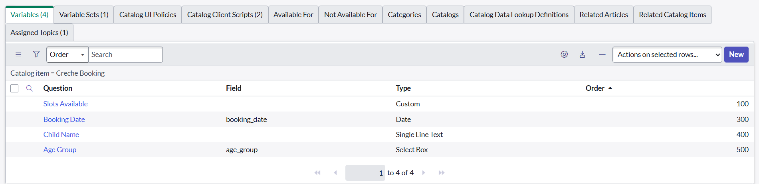

Pages:

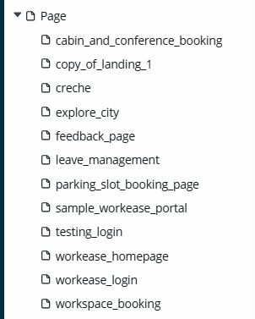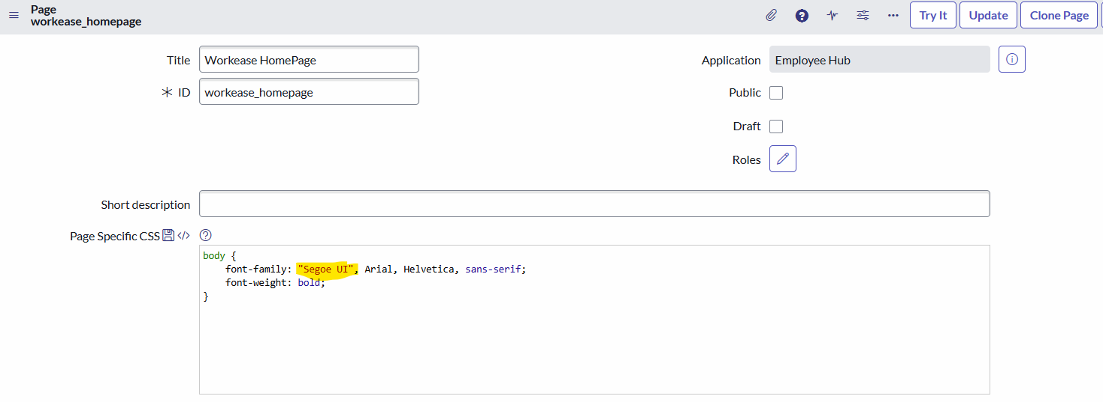

# Example Walkthrough

Catalog Item: Creche Bookings

- Form Variables:

- [Slots Available](https://ind-nov-5453-0004.lab.service-now.com/item_option_new.do?sys_id=329f98c3a8ad32107f44015294b22640&sysparm_record_target=item_option_new&sysparm_record_row=1&sysparm_record_rows=4&sysparm_record_list=cat_item%3Ddc6da3a2542172107f44e74ce76186ef%5EORDERBYorder)

- [Booking Date](https://ind-nov-5453-0004.lab.service-now.com/item_option_new.do?sys_id=62931eb2a8e132107f44015294b22696&sysparm_record_target=item_option_new&sysparm_record_row=2&sysparm_record_rows=4&sysparm_record_list=cat_item%3Ddc6da3a2542172107f44e74ce76186ef%5EORDERBYorder)

- [Child Name](https://ind-nov-5453-0004.lab.service-now.com/item_option_new.do?sys_id=a2a1732a542172107f44e74ce76186f5&sysparm_record_target=item_option_new&sysparm_record_row=3&sysparm_record_rows=4&sysparm_record_list=cat_item%3Ddc6da3a2542172107f44e74ce76186ef%5EORDERBYorder)

- [Age Group](https://ind-nov-5453-0004.lab.service-now.com/item_option_new.do?sys_id=97607b66542172107f44e74ce76186a7&sysparm_record_target=item_option_new&sysparm_record_row=4&sysparm_record_rows=4&sysparm_record_list=cat_item%3Ddc6da3a2542172107f44e74ce76186ef%5EORDERBYorder)

- Workflow:

1. Employee submits request.

2. System checks the slots availability for given date.

3. Employee receives booking confirmation via email.

4. Employee shows booking number at creche.

5. Creche authorities will verify the details and grants access.

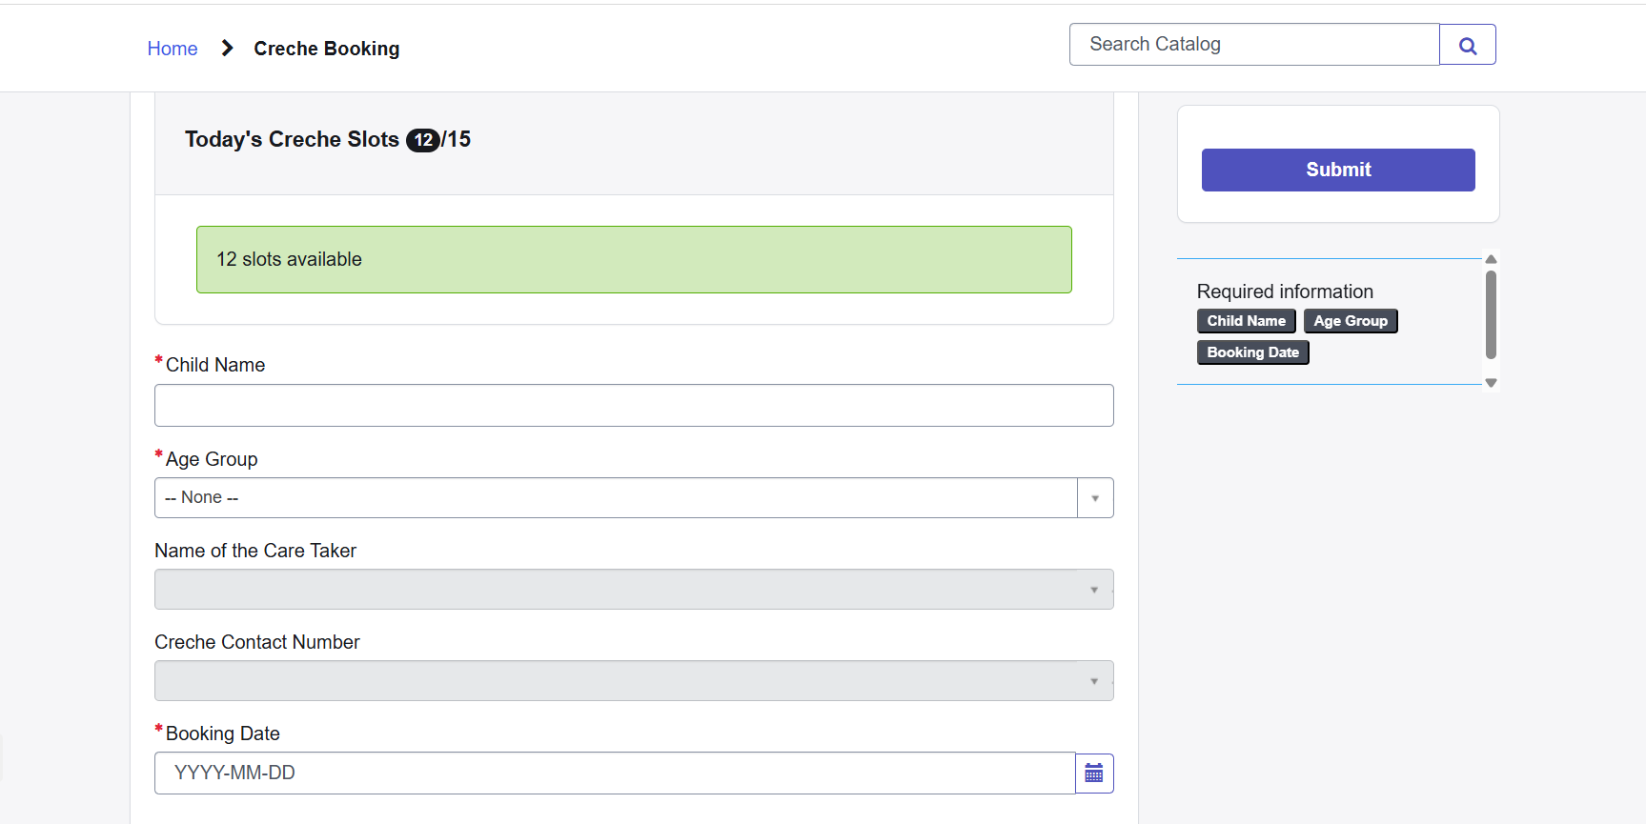

# **Challenges Faced**

- Mapping the correct categories to the catalog.

- Designing variables for forms that were both user-friendly and functional.

- Linking catalog items to flows and notifications.

- Testing catalog items for accuracy.

# **Milestone 7: Service Portal**

**Record Producer**

We have used Record producer in the project:

A Record Producer is a type of catalog item used to create records in any table through a simplified form.

To find the record producer created in this project go to All->Service Catalog->Catalogs Definitions->Record producers

Why we used Record Producer?

* Make the form simple
* Hide unnecessary fields
* Auto-populate values
* Trigger workflows or business rules

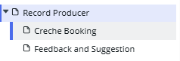

**Script used in Creche Booking:**

1. var mgr = new x_cdltd_employee_h.SlotManagerUtils();
2. var slotsLeft = mgr.getSlotsForDateDirect(producer.booking_date);
3. if (slotsLeft <= 0) {
4. current.setAbortAction(true);
5. gs.addErrorMessage("No Creched slots available for the selected date " + producer.booking_date + '.');
6. } else {
7. current.state = '1';
   1. gs.addInfoMessage("A creche booking is created for you " + current.number);
8. }

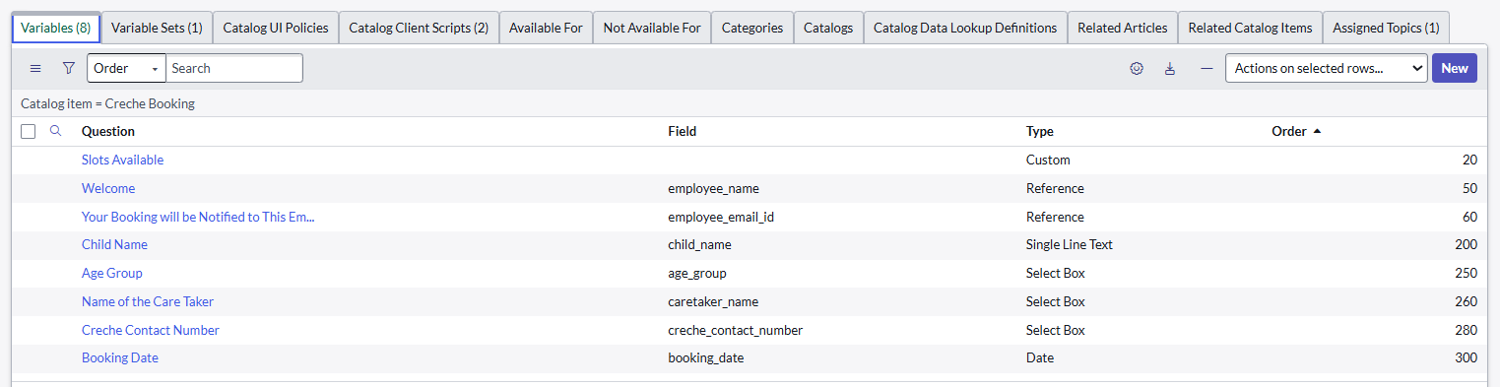

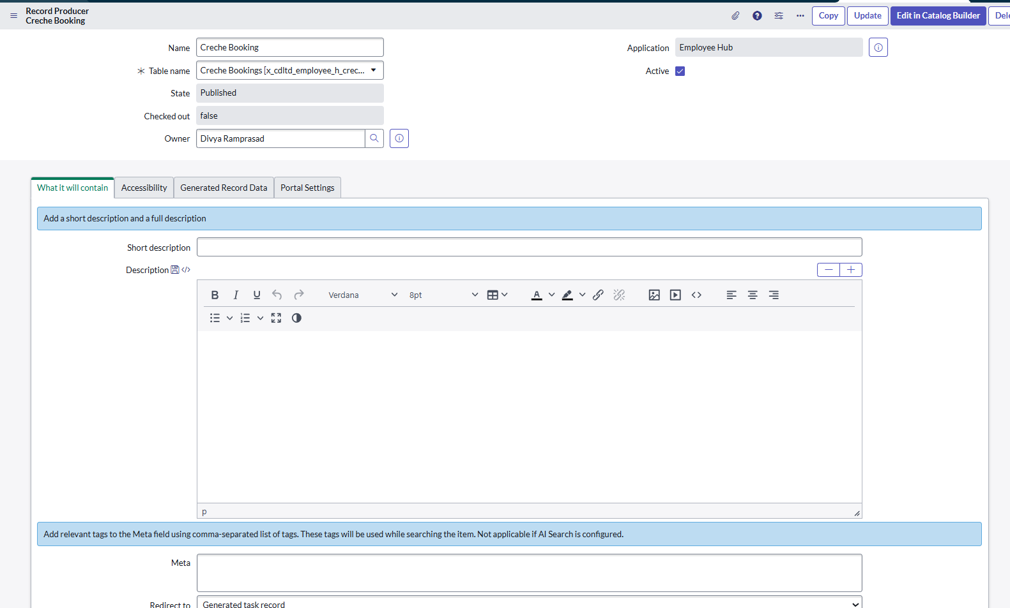

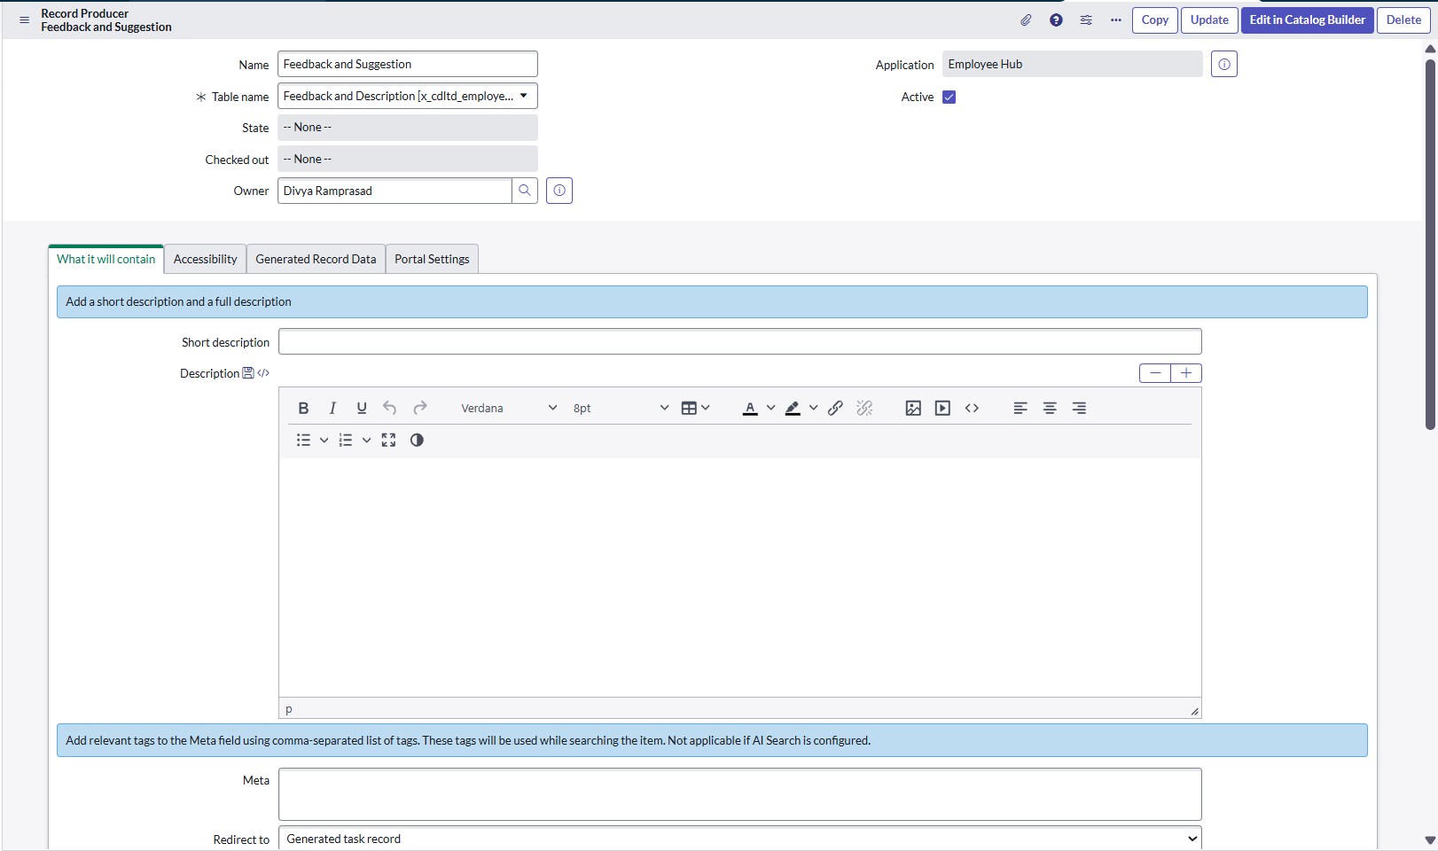

## **Activity 1: Creating the Service Portal**

### Portal Setup

- Created a new portal named Service Portal (Workease).  
- Configured the landing page with a banner.

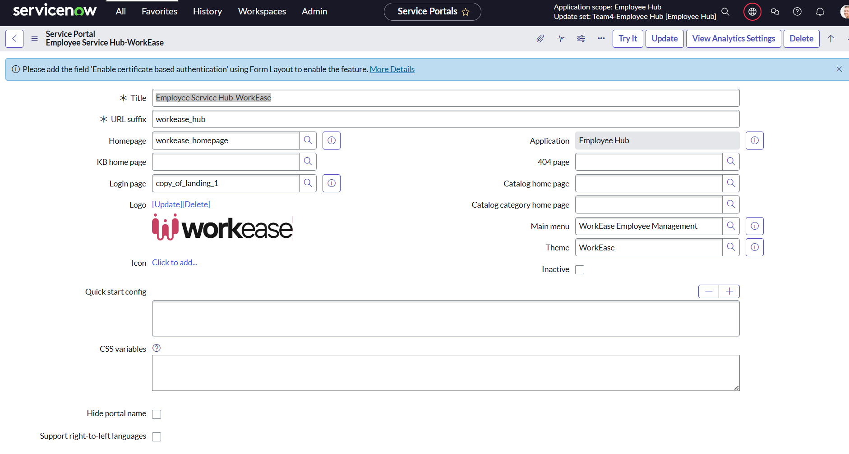

### **Activity 2: Branding**

- Added service portal logo, theme, and navigation bar (Leave Management, Knowledge article, Cabin & Conference, Creche booking, Parking Management, Explore city ).  
- Inserted banner text: “Workease” – Welcome To Workease -Employee Service Hub

### **Activity 3: Adding Widgets**

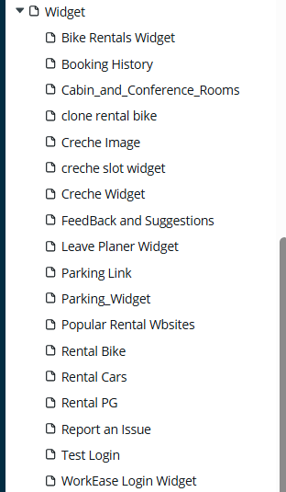

**\*We have added scripts in the comment box for all the widgets.**

**1. Cabin & Conference Rooms:**

|  |  |  |  |
| --- | --- | --- | --- |
| **HTML** | **CSS** | **Server Script** | **Client Script** |

**2. Leave Planner Widget:**

|  |  |  |  |
| --- | --- | --- | --- |
| **HTML** | **CSS** | **Server Script** | **Client Script** |

**3.Parking Widget**

|  |  |  |  |
| --- | --- | --- | --- |
| **HTML** | **CSS** | **Server Script** | **Client Script** |

**4.Creche Slot Widget**

|  |  |  |
| --- | --- | --- |
| **HTML** | **Server Script** | **Client Scipt** |

**5.Parking Link (Bike Rental)**

|  |  |  |  |
| --- | --- | --- | --- |
| **HTML** | **CSS** | **Server Script** | **Client Script** |

**6. Rental Cars**

|  |  |  |  |
| --- | --- | --- | --- |
| **HTML** | **CSS** | **Server Script** | **Client Script** |

**7.Rental PG**

|  |  |  |  |
| --- | --- | --- | --- |
| **HTML** | **CSS** | **Server Script** | **Client Script** |

**8. Report an Issue**

|  |  |  |  |
| --- | --- | --- | --- |
| **HTML** | **CSS** | **Server Script** | **Client Script** |

**9. Popular Rental Websites**

|  |  |  |  |
| --- | --- | --- | --- |
| **HTML** | **CSS** | **Server Script** | **Client Script** |

**10. Booking History**

|  |  |  |
| --- | --- | --- |
| **HTML** | **Server Script** | **Client Script** |

### **Activity 4: Script Includes (To call widgets)**

|  |
| --- |
| 1. **FeedbackUtil** |
| 1. **LeaveDateCalculator** |
| 1. **ParkingSlotUtils** |
| 1. **ReportIssueAPI** |
| 1. **ResourceBookingHelper** |
| 1. **SlotManagerUtils** |

### **Activity 5: Adding Services Section**

1. Explore City  
 2. Reserve Creche  
 3.Book Your Cabin & Conference

4.Pre book your parking slot

5.Manage your leaves

6.Feedback & Suggestions

### **Activity 6: Final Testing**

- Verified employee’s accessibity to portal  
- Tested approvals/Booking generation → triggered notification emails.  
- Tested occupancy, slot availability reduction.

# **Milestone 8: Final View “Workease_Hub" portal**

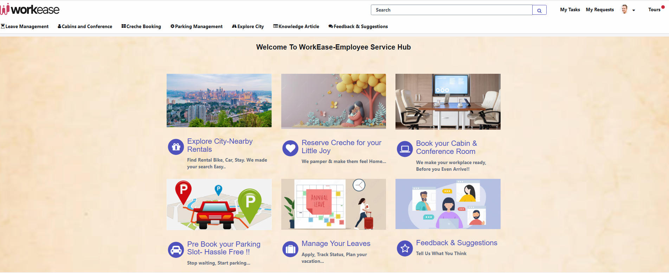

**Leave Management:**

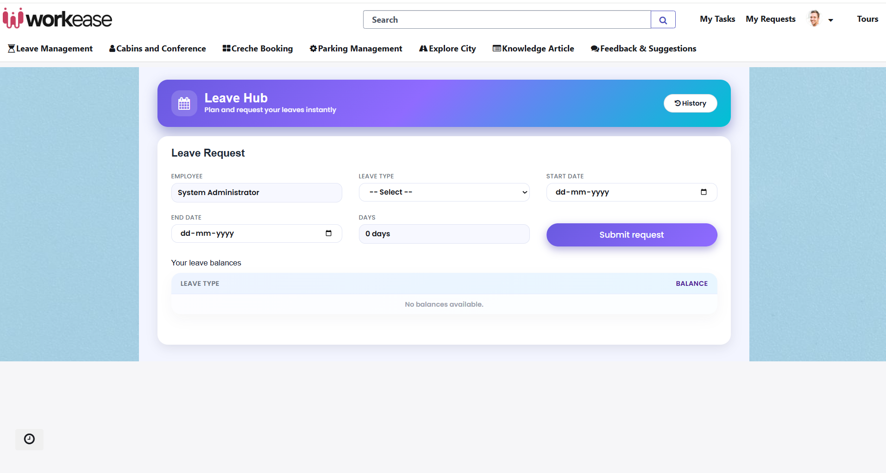

**Cabin & Conference:**

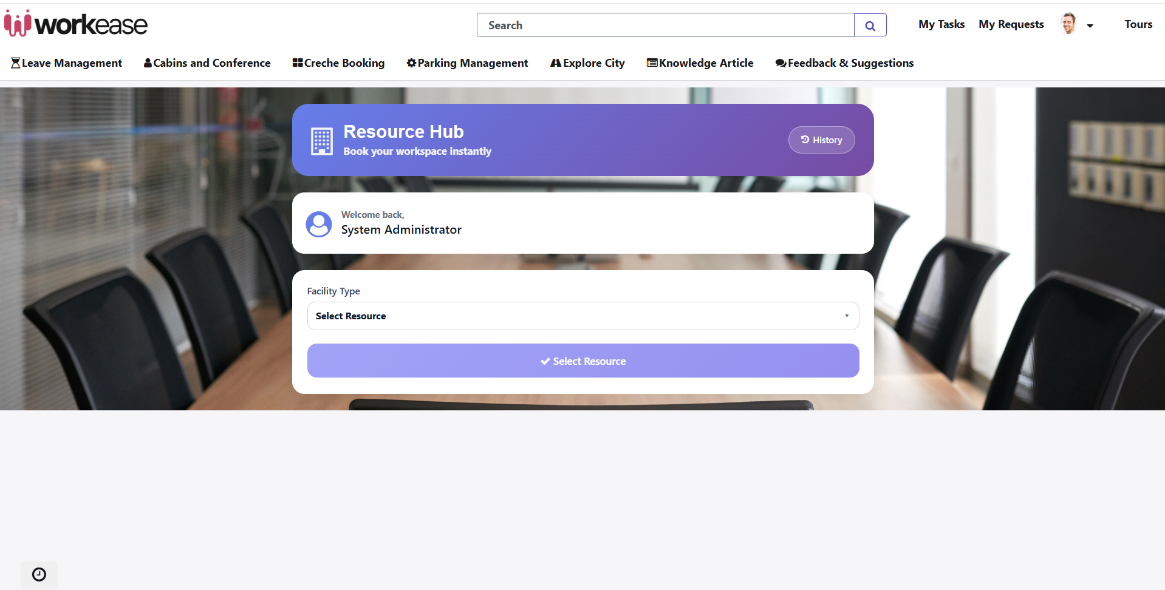

**Creche Booking:**

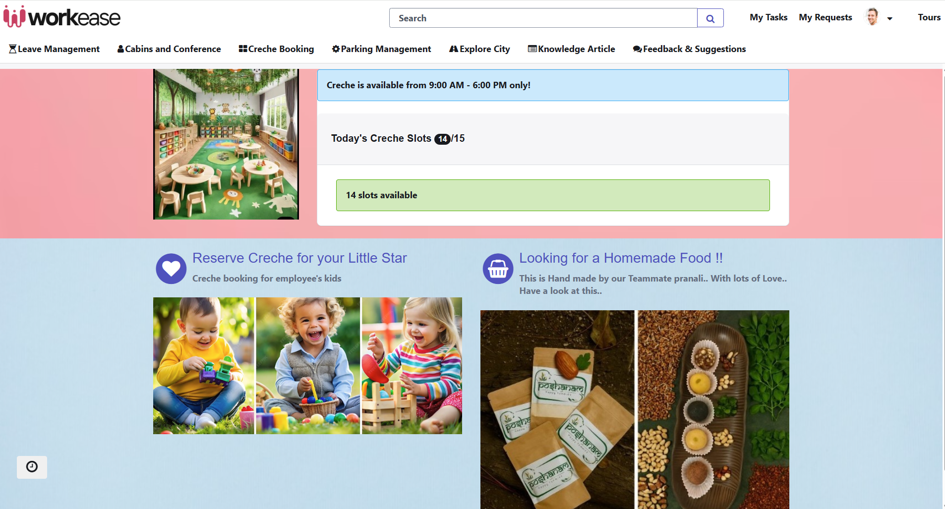

**Parking Management:**

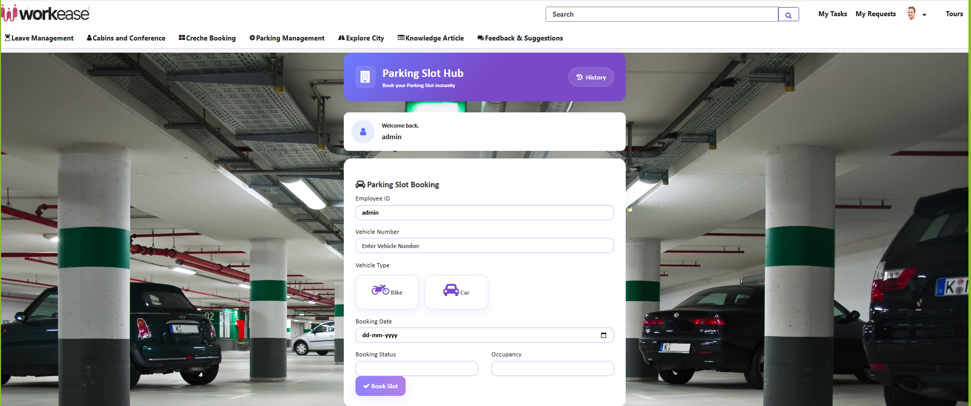

**Explore City:**

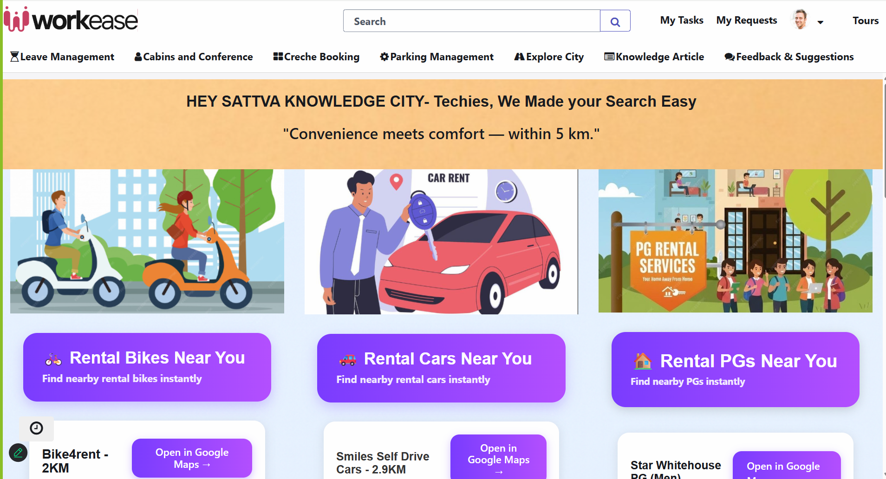

**Knowledge Article:**

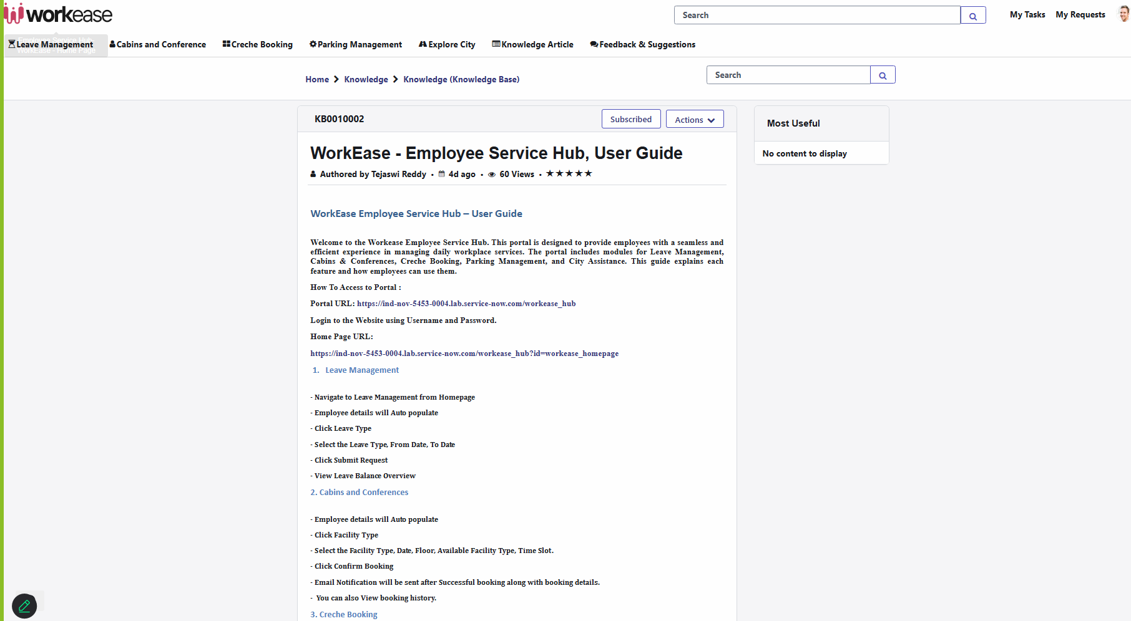

**Feedback & Suggestions:**

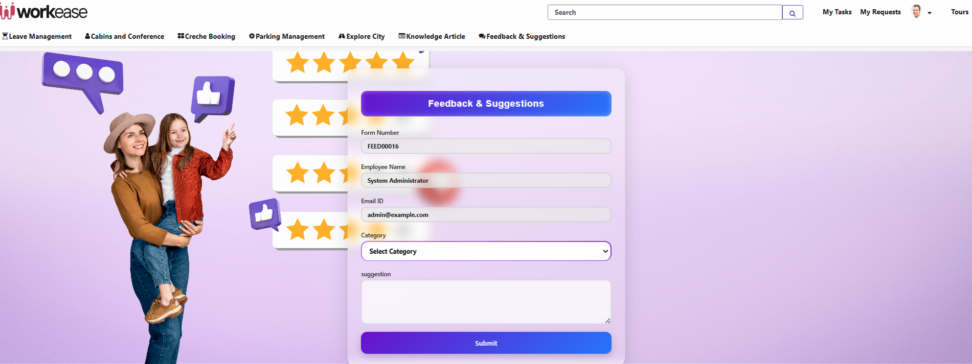

# **Conclusion**

The ServiceNow-based **Workease Employee Service Hub Project** successfully demonstrates how digital workflows can streamline and centralized operations. By creating **Catalog Items**, record producers we provided employees with a **structured, user-friendly interface** to request and manage services such as Creche booking, Parking Management, explore city.

Through the use of **client scripts, business rules**, we automated backend processes, ensuring that each request is handled efficiently and securely.

Additionally, the implementation of **Email Notifications** across the system strengthened communication between the company and its employees. Notifications ensures that:

* Employees will receive confirmation of their registration.
* Employees were updated whenever service requests were submitted.

This end-to-end integration resulted in:

* **Improved customer experience** with faster responses and transparency.
* **Reduced manual effort**
* **Better security** in managing employees and their details
* **A scalable solution** that can be expanded with new services in the future.

Overall, the project demonstrates how **ServiceNow’s low-code/no-code platform** can be leveraged to deliver practical, real-world solutions in the industry. It highlights our ability to design, configure, and deploy an enterprise-grade system that aligns with modern business needs, while ensuring usability, efficiency, and reliability.

**Future Scope**

Third-party payment gateway integrations

Mobile application development outside ServiceNow's native app

Improving services in IT Infrastructure

**Thankyou !!!**